

**GROUP ASSIGNMENT**

**TECHNOLOGY PARK MALAYSIA**

**PROJECT MANAGEMENT**

**CT050-3-3-PRMGT**

**UC3F1701SE**

**DATE ASSIGNED: 10th February 2017**

**DATE COMPLETED: 17th April 2017**

**WEIGHTAGE: 100%**

**INSTRUCTIONS TO CANDIDATES:**

1. **Submit your assignment at the administrative counter.**
2. **Students are advised to underpin their answers with the use of references (cited using the Harvard Name System of Referencing).**
3. **Late submission will be awarded zero (0) unless Extenuating Circumstances (EC) are upheld.**
4. **Cases of plagiarism will be penalized.**
5. **The assignment should be bound in an appropriate style (comb bound or stapled).**
6. **The assignment should be submitted in both hardcopy and softcopy, the softcopy of the written assignment and source code (where appropriate) should be on a CD in an envelope / CD cover and attached to the hardcopy.**

**7. You must obtain 50% overall to pass this module.**



|  |  |  |
| --- | --- | --- |
| **MODULE** | **:** | CT050-3-3-PRMGT PROJECT MANAGEMENT |
| **GROUP NAME** | **:** | PROXIMITY |
| **INTAKE CODE** | **:** | UC3F1701SE |
| **GROUP MEMBER 1** | **:** | HUA CHYE YEE TP032037 |
| **GROUP MEMBER 2** | **:** | NGUI TZE KEN TP031955 |
| **GROUP MEMBER 3** | **:** | THUM CHOON TAT TP030470 |
| **GROUP MEMBER 4** | **:** | CHEE YONG YI TP031763 |
| **HAND OUT DATE** | **:** | 10 FEBRUARY 2017 |
| **HAND IN DATE** | **:** | 17 APRIL 2017 |
| **COURSEWORK TITLE** | **:** | GLOBAL SUPPLY CHAIN MANAGEMENT PROJECT |

Table of Contents

1 Project Methodology 1

1.1 Kanban 1

1.2 Scrum 2

1.3 Implementation 3

2 Project Charter 4

2.1 Background 4

2.2 Objectives 4

2.3 Scope 4

2.3.1 Product Scope 4

2.3.2 Project Scope 5

2.4 Constraints 5

2.5 Assumptions 5

2.6 Risks 6

2.7 Roles, Responsibilities and Stakeholders 6

2.8 Milestone 7

2.9 Critical Success Factor 8

2.10 High-Level Budget 8

2.11 Team Operating Principle 9

2.12 Project Management Authority 9

2.13 Signatures 10

3 Scope Statement 11

3.1 Product Scope 11

3.2 Project Scope 13

3.3 Scope Out / Boundary 14

4 Work Breakdown Structure 15

5 Gantt Chart 16

6 Network Diagram 22

7 Cost Budgeting 23

8 Quality Management 25

8.1 Planning 25

8.2 Assurance 26

8.3 Control 26

9 Cutover Strategy and Transition Plan 27

10 Lessons Learned 28

11 Project Management Knowledge Areas 29

11.1 Human Resource – Ngui Tze Ken TP031955 29

11.1.1 Plan Human Resource Management 30

11.1.2 Acquire Project Team 38

11.1.3 Develop Project Team 39

11.1.4 Manage Project Team 41

11.1.5 Conclusion 44

11.2 Communication – Hua Chye Yee TP032037 45

11.2.1 Plan Communication Management 46

11.2.2 Manage Communications 57

11.2.3 Control Communications 60

11.2.4 Conclusion 61

11.3 Risk – Chee Yong Yi TP031763 62

11.3.1 Plan Risk Management 63

11.3.2 Identify Risk 66

11.3.3 Perform Qualitative Risk Analysis 67

11.3.4 Perform Quantitative Risk Analysis 69

11.3.5 Plan Risk Responses 69

11.3.6 Control Risks 72

11.3.7 Conclusion 76

11.4 Procurement – Thum Choon Tat TP030470 77

11.4.1 Introduction 77

11.4.2 Plan procurement management 78

11.4.3 Conduct procurement 83

11.4.4 Control procurement 85

11.4.5 Close procurement 87

11.4.6 Conclusion 89

12 References 90

13 Appendix 95

# Project Methodology

After comparing with several other development methods such as waterfall and RUP, Kanban used in conjunction with Scrum was chosen as the most suitable methodology for this project. As our project – Global Supply Chain Management Project, can be divided into distinct tasks, and delivery of the project by the deadline is crucial, the Kanban method is perfect for enforcing continuous progression of the project so that it is completed on time. Also, given that it is such a simple method to implement, it would save a lot of time and effort compared to most other methodologies. Using Scrum in conjunction with Kanban allows for it to be better managed and be more effective.

## Kanban

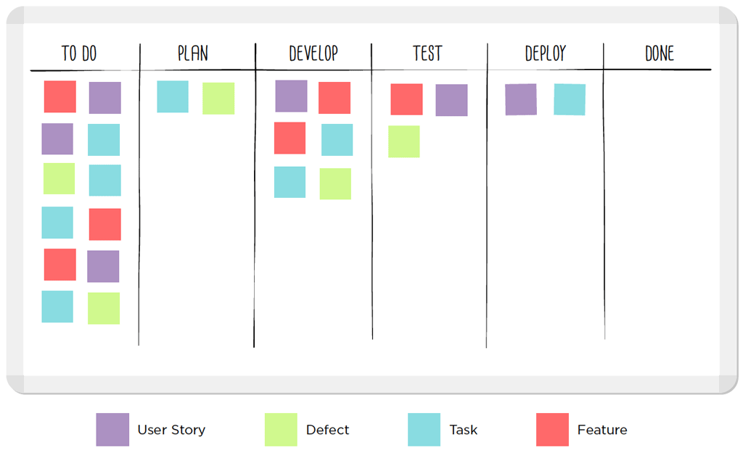Kanban is a lean scheduling system developed in Japan by Toyota and was adapted for use in software development. It emphasizes on just-in-time delivery while not overloading team members. The key to Kanban is that it is a visual representation of all the tasks, so having a whiteboard or an application to show the state of the project is vital. It works by categorizing the project’s tasks into several distinct stages such as “To-Do”, “In-Progress” and “Done”. The “In-Progress” stage can be further divided into more detailed stages if needed. Tasks are then laid out onto the board on the “To-Do” stage. Team members will then take tasks and begin working on them from the “To-Do” stage. As soon as that happens, the task is moved to the next stage and when that task is finished with its current stage, it moves up to the next again until it arrives at the “Done” stage. Now the important part is imposing a limit on the number of tasks that can stay at one stage. For example, if there were “Develop” and “Test” stages on the board, and a limit of 6 tasks is set for the whole board, whenever there are 6 tasks on the “Develop” stage, team members can visually see a congestion and must work to get those tasks moving to the “Test” stage before working on anything else. This ensures that tasks are constantly being worked on.

## Scrum

Scrum is an agile framework designed to work with complex software development projects. It is designed to cut away unnecessary collections of mandatory components that are tightly interwoven and instead provide a simpler, heuristic approach to managing projects. Scrum is made up of several key components which will produce an incrementally more complete result. Below is an illustration of the Scrum framework

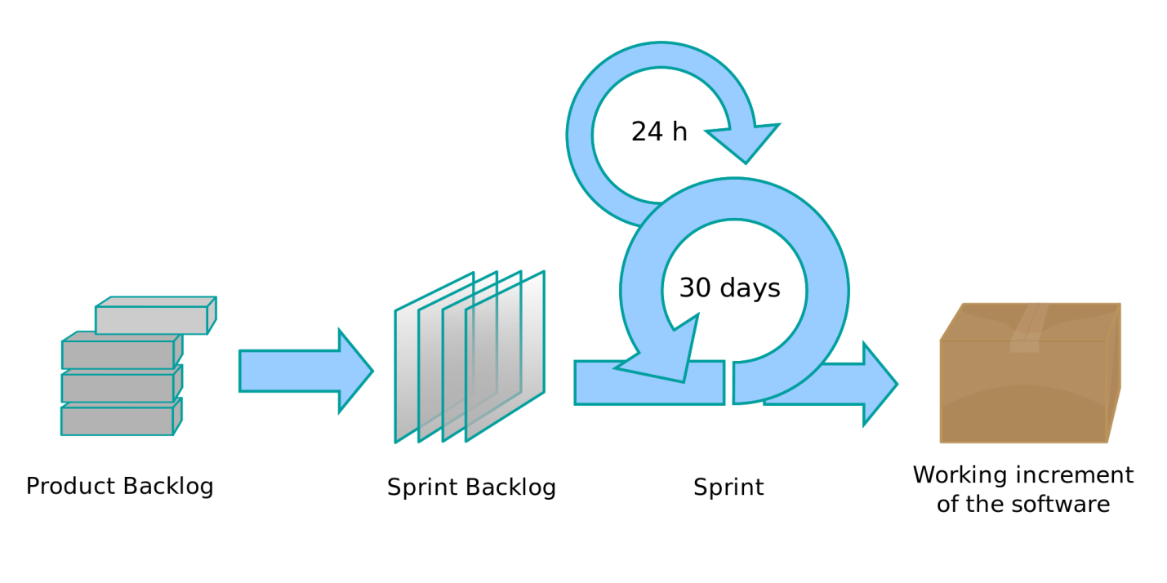

The scrum methodology consists of the scrum team, which will conduct what is called a daily scrum to brief on what has been done and what needs to be done. Products from the product backlog are grouped into sprints which are then taken on by the scrum team for development. Upon completing a sprint, the scrum team will conduct a sprint retrospective meeting and produce an incrementally better software output. From there the process is repeated as the next item in the product backlog goes through the same sequence of events. These activities are overseen by a person known as the Scrum master. The Scrum master is responsible for ensuring the daily scrum meetings are conducted as well as maintaining the scrum backlog to ensure the project continues to progress.

## Implementation

In the context of the Global Supply Chain Management Project, each development module will be broken down into individual tasks, then phases of each task will be determined to build the Kanban board. The team will then execute the tasks based on the rules of Kanban. Separate boards will be used for each module such as the yard management module and order management module as they will run simultaneously. Scrum will be used to manage the overall project, with daily Scrum meetings held to ensure the project is progressing correctly. A Scrum master will be tasked to ensure the project stays on track as well.

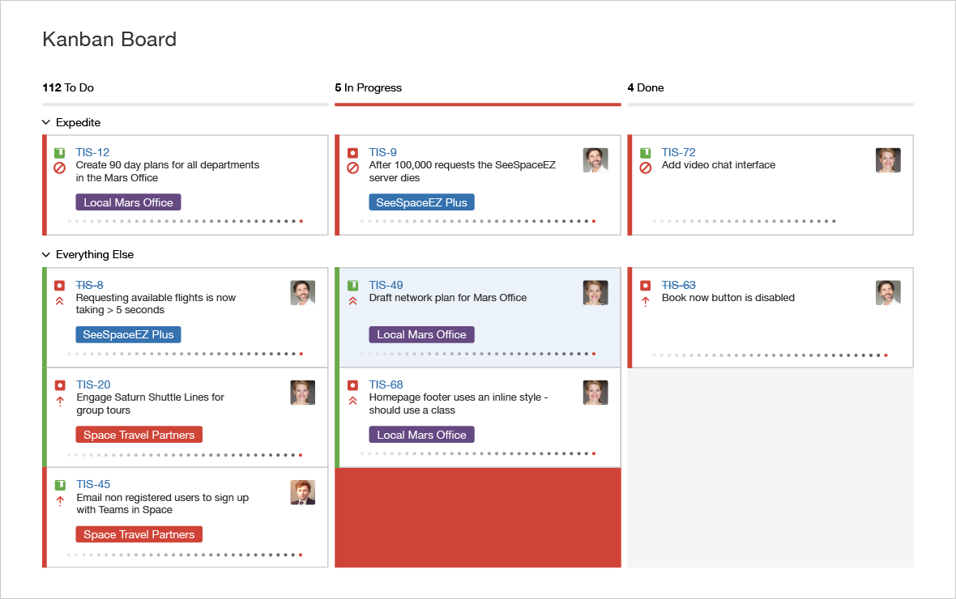

Instead of using a physical board for Kanban which may become hard to manage, Jira – a software alternative which will implement both Kanban and Scrum together will be used to keep track of the project progress. Jira allows for a software representation of a Kanban board as well as Scrum functionality such as burndown charts, backlog tracking as well as task assignment to individual team members as shown in the image above. For higher management, Jira will also be able to produce progress reports with charts such as burndown charts to give a detailed overview of the progress that is being made in the project.

# Project Charter

## Background

Healthy Living Pte. Ltd. (HL) is one of the leading nutrition, health and wellness multinational companies, based in Singapore with its global IT shared services known as Global IT Services (GITS) located in Malaysia has embarked on a new project to its enhance supply chain operations. The first wave will be concentrated to South East Asia and the implementation will be deployed by markets.

At present, markets located throughout South East Asia are using locally developed application to record supply chain management activities information. The first-level support (L1) is being rendered by local IT and second level (L2) is supported by the local application vendor. Previously the cost for software support maintenance was managed locally within each market which has resulted high in IT cost for both capital and operating expenses. Unfortunately, every market provides similar support framework which has created duplication among markets within the Southeast Asia Region due to decentralization of systems being used. Thus, by implementing this project, significant contribution such as reduction in capital/operating expenses, centralized support from GITS, global governance and many more value added are gained.

## Objectives

* Develop and deliver a system with all the common functions that can be found in typical Supply Chain Management software
* Facilitate users to make quicker decision in managing inventory in their own region
* Centralize support from GITS
* Reduce capital and operating expenses

## Scope

### Product Scope

1. Supplier Management Module
2. Transportation Management Module
3. Yard Management Module
4. Warehouse Optimisation Module
5. Manufacturing Management Module
6. Inventory Management Module
7. Labour Management Module
8. Product Management Module
9. Customer Requirements Module
10. Order management Module

### Project Scope

1. Identify stakeholders
2. Conduct feasibility study
3. Develop project charter
4. Plan project
5. Gather requirements
6. Design system
7. Develop system
8. Test system
9. Transition to new system

## Constraints

1. Time constraint to develop the system as there is an urgency for centralizing support and cost reduction.
2. Resource and support can only be acquired from HL Malaysia and GITS respectively.
3. The deadline for this project cannot be pushed back.
4. Transition from current system to new system must be in parallel.
5. Project team has limited skills set.

## Assumptions

1. The project documentations from the previous project team are accessible by the new project team and can be reused.
2. Sponsors are willing to continue funding the project
3. All existing IT infrastructures are reusable.
4. Project can be outsourced to vendors.
5. A data warehouse will be provided to the project team by HL when the system is ready to be deployed.
6. Data found in existing system is not centralized and formatted similarly.
7. Heathy Living has an active internship program which the members can be reassigned to other projects.

## Risks

| Risk | Mitigation |
| --- | --- |
| Unable to deliver the system on time | Hire more developers to speed up the development |
| Cost overrun | Reuse existing hardware and components |
| Frequent change of requirements | Tightening up the approval process for change of requirements |
| Inexperienced developers | Replace inexperienced developers with more qualified developers |
| Module compatibility issue | Connect incompatible modules with API |

## Roles, Responsibilities and Stakeholders

|  |  |  |
| --- | --- | --- |
| **Role** | **Responsibility** | **Name** |
| Project Manager | Deliver the deliverables and manage project team. | Hua Chye Yee |
| Project Team | Manage project schedule and functional managers | Susanne Sundfør |
| Human Resource Manager | Manages the Human Resource Team | Ngui Tze Ken |
| Human Resource Team | Recruit or hire employees and managing relations between employees. | John Conner, Kobayashi Maru |
| Procurement Manager | Manage Procurement team and meet with potential vendors | Thum Choon Tat |
| Procurement Team | Collaborate with project manager to make decision on procurement items specification. | Ken Chan, Olivia Thatcher |
| Finance Manager | Make decision on the resources required based on project budgets. | Abraham Fletcher |
| Business Analyst | Analyses and documents business domain | Chee Yong Yi |
| Supply Chain Management SME | Conduct operational feasibility study to measure the ability of the deliverable to solve problems. | Healthcare Medical Inc |
| Software Vendors | Develop and deliver modules within the deliverables provided. | Microsoft, Oracle, IBM |
| Interns | Join project team to deliver the deliverables. | Jyothi Jitender, Mohan Maninder |
| Quality Assurance Team | Ensure and maintain the quality of the deliverables. | Prasanna Manas, Zheng Zhi Hao |
| Development Head | Leads the development team. | Dajason Kumar |
| Development Team | Develop the deliverables of the project. | Jian Gang, Chandra Xue |
| System Administrator | To setup and deploy the deliverables of the project. | Guiying Jie |
| Steering Committee | Manage requirements changing requests, system proposal approval and conduct user acceptance test meetings | Heng Inderpal, Hong Xinyi |
| System User | Attend to user acceptance test meetings | Healthy Living |

## Milestones

|  |  |  |
| --- | --- | --- |
| **Milestones** | **Date** | **Milestone Description** |
| Project Start | 7 Feb 2017 | Mark the beginning of the GSCMP |
| Project Approved | 21 Feb 2017 | Project charter has been approved and ready to start |
| Project Plan Completed | 6 Mar 2017 | A plan has been developed for GSCMP |
| GSCMP Design Ready | 25 April 2017 | System design has been produced and ready for development |
| GSCMP Development Completed | 3 June 2017 | Ended development phase and produced the system |
| Testing Completed | 10 June 2017 | System has been proven to be production-ready and have passed user acceptance test |
| GSCMP Live Alongside Old System | 20 June 2017 | New system is running alongside the old system awaiting regression testing |
| GSCMP Fully Functional | 26 June 2017 | Old system has been completely replaced by the new system for the Malaysia market |
| Project Completed | 1 July 2017 | Mark the end of the GSCMP |

## Critical Success Factors

1. Capable resources would be selected from any of the SME-departments the current IT infrastructure must support this new system
2. Its mandatory for related GITS-SMEs to provide approval and signoff for system implementation
3. All support staff and users must have access to this new system with relevant Access Level (ACL) privileges
4. The current system must be replaced in phases by GSCMP.
5. The cutover must be conducted in parallel

## High-Level Budget

|  |  |
| --- | --- |
| Component | Estimated Cost ($USD) |
| Modules |  |
| * Supplier Management Module | $8,900.00 |
| * Transportation Management Module | $10,800.00 |
| * Yard Management Module | $9,300.00 |
| * Warehouse Optimisation Module | $12,800.00 |
| * Manufacturing Management Module | $11,700.00 |
| * Inventory Management Module | $10,300.00 |
| * Labour Management Module | $9,200.00 |
| * Product Management Module | $8,600.00 |
| * Customer Requirements Module | $9,500.00 |
| * Order management Module | $10,700.00 |
| Hardware |  |
| * Servers | $40,000.00 |
| * UPS | $2,500.00 |
| * Back up devices/Disk storage | $4,000.00 |
| Software |  |
| * Server OS licenses | $6,000.00 |
| * Server software (security suite, mail server, etc.) | $15,000.00 |
| Network | $18,000.00 |
| Testing | $52,000.00 |
| Deployment |  |
| * Data clean up | $2,000.00 |
| * System migration | $10,000.00 |
| Training |  |
| * Training key users | $6,600.00 |
| * Training materials | $250.00 |
| * Travel and expenses to attend training | $2,000.00 |
| **Total** | **$260,150.00** |

## Team Operating Principles

1. Treat each other with respect
2. Be punctual to work and meeting all the time
3. Be open and honest with each other
4. Make decisions as a team with the result in mind
5. Encourage, support and help each other
6. Commit to work and finish task in time
7. Be productive during working hour
8. Resolves disagreement by finding common ground
9. Have patience with each other
10. Take responsibility for your actions and willing to learn from mistakes
11. Seek for improvements constantly
12. Listen to and communicate with each other

## Project Management Authority

To ensure the project can be carried out smoothly, the team and project manager have decided and agreed to give the following authority and rights to project manager:

1. Project manager can call committee, managers, project team for meeting and discussion
2. Project manager can approve budget, requirements changes
3. Project manager can distribute/allocate/coordinate resources
4. Project manager can request resources from IT departments
5. Project manager can communicate with vendors, treasurer and committee directly
6. Project manager can reject/cancel requirements or activities if deemed too risky or not feasible

## Signatures



# Scope Statement

## Product Scope

**Supplier Management Module**

This module helps the organization to manage and control the engagement with suppliers. Additionally, the module includes tools to manage and verify orders from suppliers which directly helps to minimize risk as well as to lessen the operational costs.

**Transportation Management Module**

Transportation Management Module is part of the supply chain management system concerning about transportation operations. It is used to manage and monitor all transportation activity.

**Yard Management Module**

This module is often used in conjunction with warehouse optimisation module and transportation module to track and oversee the movement of trucks and trailers in the yard of a manufacturing facility, warehouse, or distribution centre.

**Warehouse Optimisation Module**

This module is used to support the day-to-day operations in a warehouse by providing functions to control and track the inventory in the warehouse.

**Manufacturing Management Module**

This module is used to oversee the manufacturing line of the organization. It enables the organization to plan, monitor and control the production related activities to increase the efficiency and manufacturing production capacity.

**Inventory Management Module**

This module allows the finished products to be monitored and controlled. It is mainly used to track the quantity and whereabouts of the stock. In addition, it contains reporting tool for the senior management.

**Labour Management Module**

Labour Management module is primary used by HR department to manage as well as track the performance of human resource within an organization. The labours’ statistics can then be used when making crucial decisions.

**Product Management Module**

This module is used to manage and track launched products as well as their information. It also used to plan the future products and helps to market them to the right audience and region based on their sales statistics.

**Customer Requirements Module**

This module is used to verify if the available stocks can meet customers’ needs and expectations and process their requirements.

**Order management Module**

This module contains vital functions like accounting, payment services, and fraud prevention to process, complete and tracks an order. It also allows an order to be amended and support for order return processing.

## Project Scope

**Identify stakeholders**

Before the project start, the stakeholders are first determined to keep all of them involved during the project lifecycle. This is since their requirements and expectations are the key factor to ensure the success of this project.

**Conduct feasibility study**

The feasibility of this project in terms of technical, operational, resources, cost and legal aspects are then assessed to verify if this project can be done.

**Develop project charter**

A project charter that outlines the project details, objectives, budget, roles and responsibilities is then produced for the board of directors of HL and sponsor of this project.

**Plan project**

Once the project charter has been approved, the planning phase commences. This phase concerns about setting up the project team for this project such as choosing a system development method, assign roles, develop Gantt chart and allocate budget.

**Gather requirements**

The requirements of this project are then collected through several requirements gathering methods and are then documented for future references.

**Design system**

The designs of the system such as its database design, UI design and related UML diagrams are then prepared for the development team and vendors to refer when building the system.

**Develop system**

After the system design has been produced, the system will then be developed by the development team and vendors.

**Test system**

Once the system has been developed, system will go through several tests and user acceptance test to ensure the system meet all the requirements are suitable for production environment.

**Transition to new system**

A parallel cutover strategy will be devised to transition the old system to the new system to ensure a smooth deployment, migration and cutover.

## Scope Out / Boundary

The GSCM project is only concerned about the supply chain management system for HL Malaysia and not for the other country branches. Hence, only the supply chain management system and associated modules mentioned are in the scope for this project. Although some of the modules and its functionalities share a lot of similarities with enterprise resource planning (ERP) system counterparts, building an ERP is not part of the product scope. Upon completion of the GSCM project, system maintenance, software and hardware upgrades will not be the concern of this project team as they are excluded from the scope of the project. In addition, it should also be noted that the modules listed only concerns the resources and processes found in HL’s supply chain.

# Work Breakdown Structure

|  |  |
| --- | --- |
| WBS | Task Name |
| **1** | **GSCMP** |
| **1.1** | **Initiation Phase** |
| 1.1.1 | Project Start |
| **1.1.2** | **Evaluation & Recommendation** |
| **1.1.3** | **Develop Project Charter** |
| **1.1.4** | **Project Charter Approval** |
| 1.1.5 | Project Approved |
| **1.2** | **Planning Phase** |
| **1.2.1** | **Create Scope Statement** |
| **1.2.2** | **Determine Project Team** |
| **1.2.3** | **Project Planning** |
| **1.3** | **Execution Phase** |
| **1.3.1** | **User Requirement Specification** |
| **1.3.2** | **Procurement** |
| **1.3.3** | **Task/Module Breakdown** |
| 1.3.3.1 | Supplier Management Module |
| 1.3.3.2 | Transportation Management Module |
| 1.3.3.3 | Yard Management Module |
| 1.3.3.4 | Warehouse Optimisation Module |
| 1.3.3.5 | Manufacturing Management Module |
| 1.3.3.6 | Inventory Management Module |
| 1.3.3.7 | Labour Management Module |
| 1.3.3.8 | Product Management Module |
| 1.3.3.9 | Customer Requirements Module |
| 1.3.3.10 | Order Management Module |
| 1.3.3.11 | Kanban Tasks Listing with JIRA |
| **1.3.4** | **System Design** |
| 1.3.5 | GSCM Design Ready |
| **1.3.6** | **System Development** |
| **1.3.6.1** | **Phase 1** |
| **1.3.6.1.1** | **Supplier Management Module** |
| **1.3.6.1.2** | **Transportation Management Module** |
| **1.3.6.1.3** | **Yard Management Module** |
| **1.3.6.1.4** | **Closing Phase** |
| **1.3.6.2** | **Phase 2** |
| **1.3.6.2.1** | **Warehouse Optimisation Module** |
| **1.3.6.2.2** | **Manufacturing Management Module** |
| **1.3.6.2.3** | **Inventory Management Module** |
| **1.3.6.2.4** | **Closing Phase** |
| **1.3.6.3** | **Phase 3** |
| **1.3.6.3.1** | **Labour Management Module** |
| **1.3.6.3.2** | **Product Management Module** |
| **1.3.6.3.3** | **Customer Requirements Module** |
| **1.3.6.3.4** | **Closing Phase** |
| **1.3.6.4** | **Phase 4** |
| **1.3.6.4.1** | **Order Management Module** |
| **1.3.6.4.2** | **Integration of Modules** |
| **1.3.6.4.3** | **Closing Phase** |
| 1.3.7 | GSCM Development Completed |
| **1.3.8** | **System Testing** |
| **1.3.9** | **User Acceptance Test** |
| 1.3.10 | Testing Completed |
| **1.3.11** | **System Installation** |
| **1.3.12** | **Complete Cutover** |
| 1.3.13 | GSCM Fully Functional |
| **1.4** | **Controlling Phase** |
| **1.4.1** | **Risk Management** |
| **1.4.2** | **HR Management** |
| **1.4.3** | **Quality Deliverables** |
| **1.4.4** | **Scrum** |
| **1.4.5** | **Weekly Progress Meeting** |
| **1.4.6** | **Budget Report & Resource Reallocation** |
| **1.5** | **Closing Phase** |
| **1.5.1** | **Documentation** |
| **1.5.2** | **Formal Acceptance & Information** |
| 1.5.3 | Project Completed |

# Gantt Chart

Refer to the following page

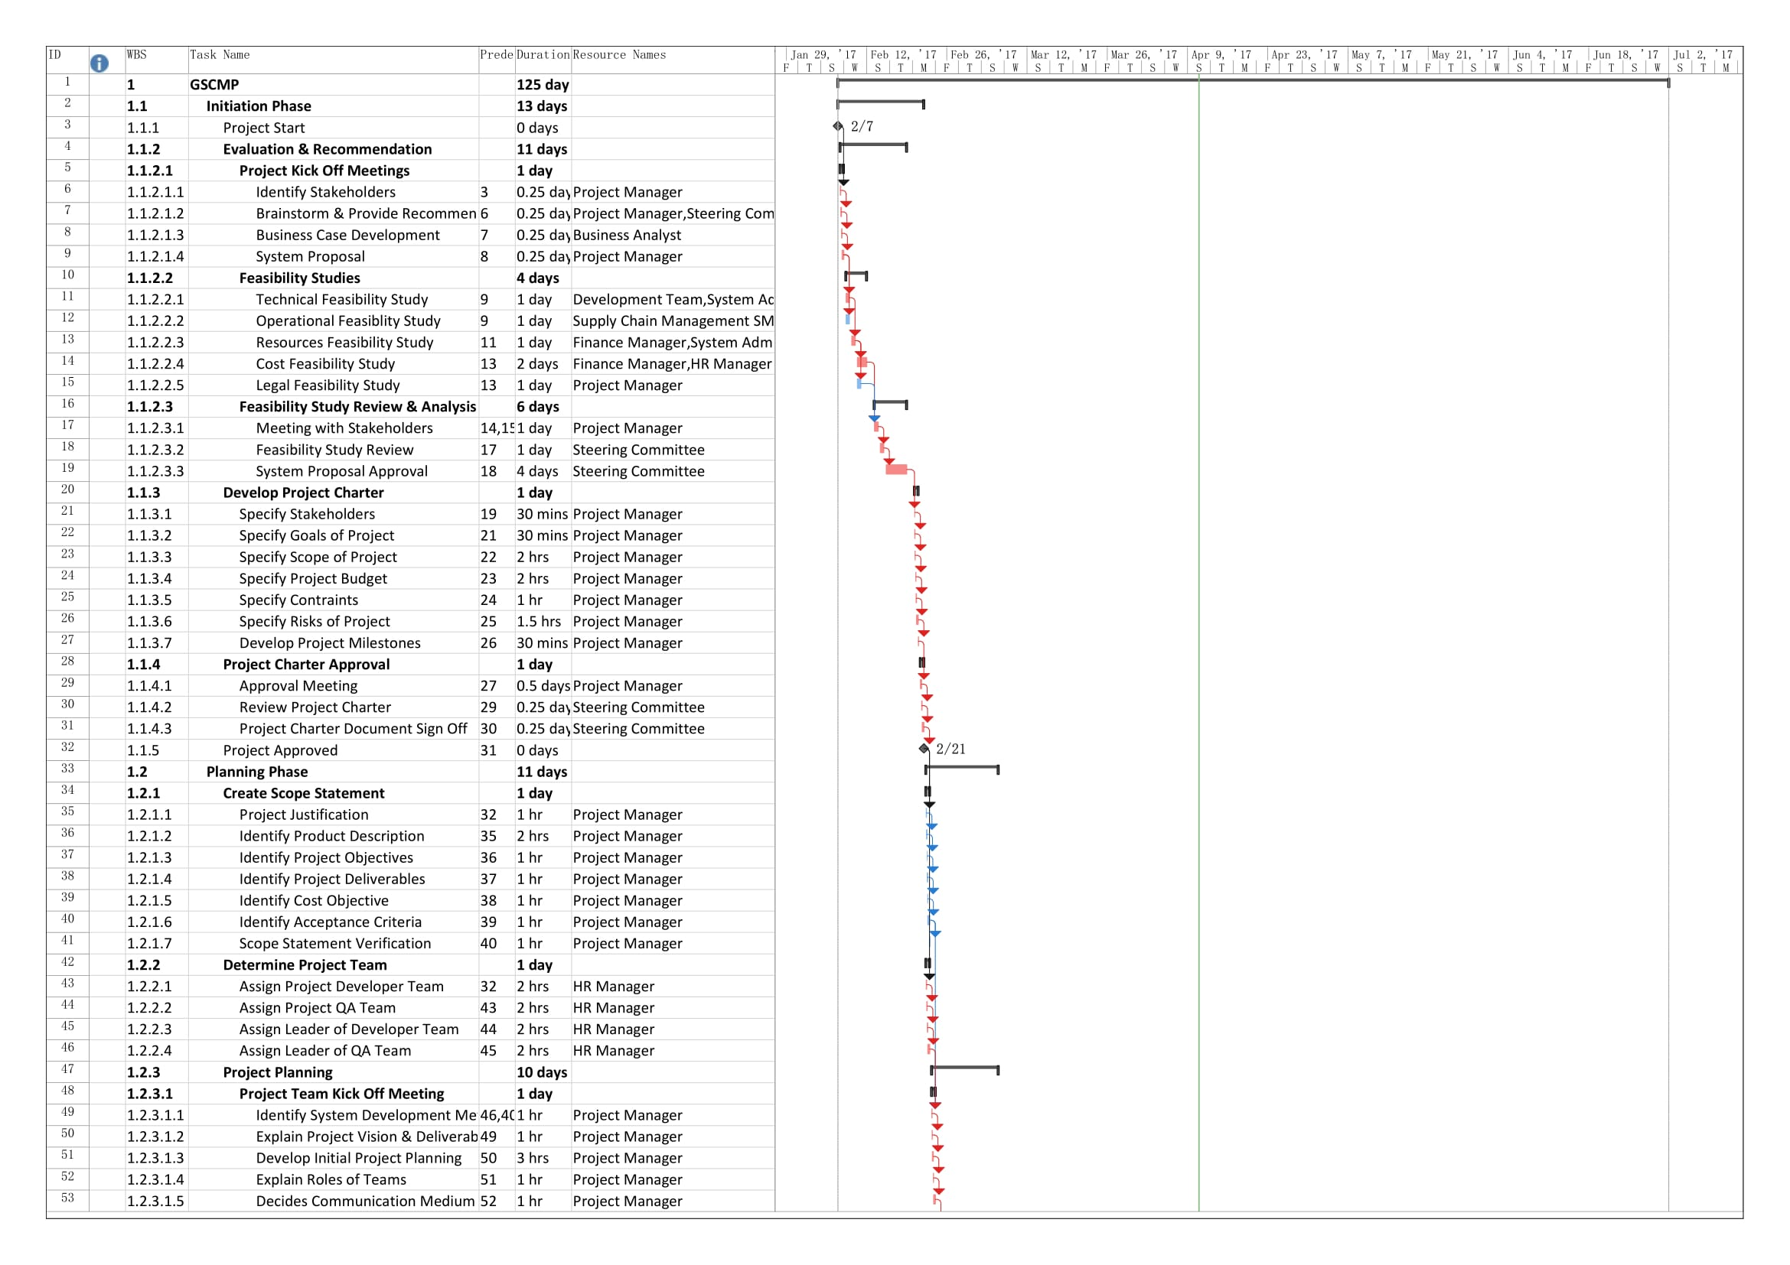

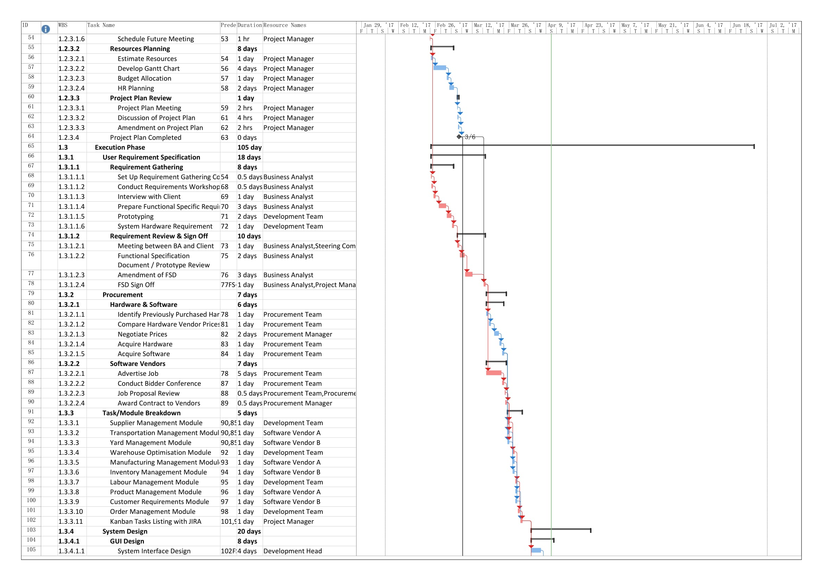

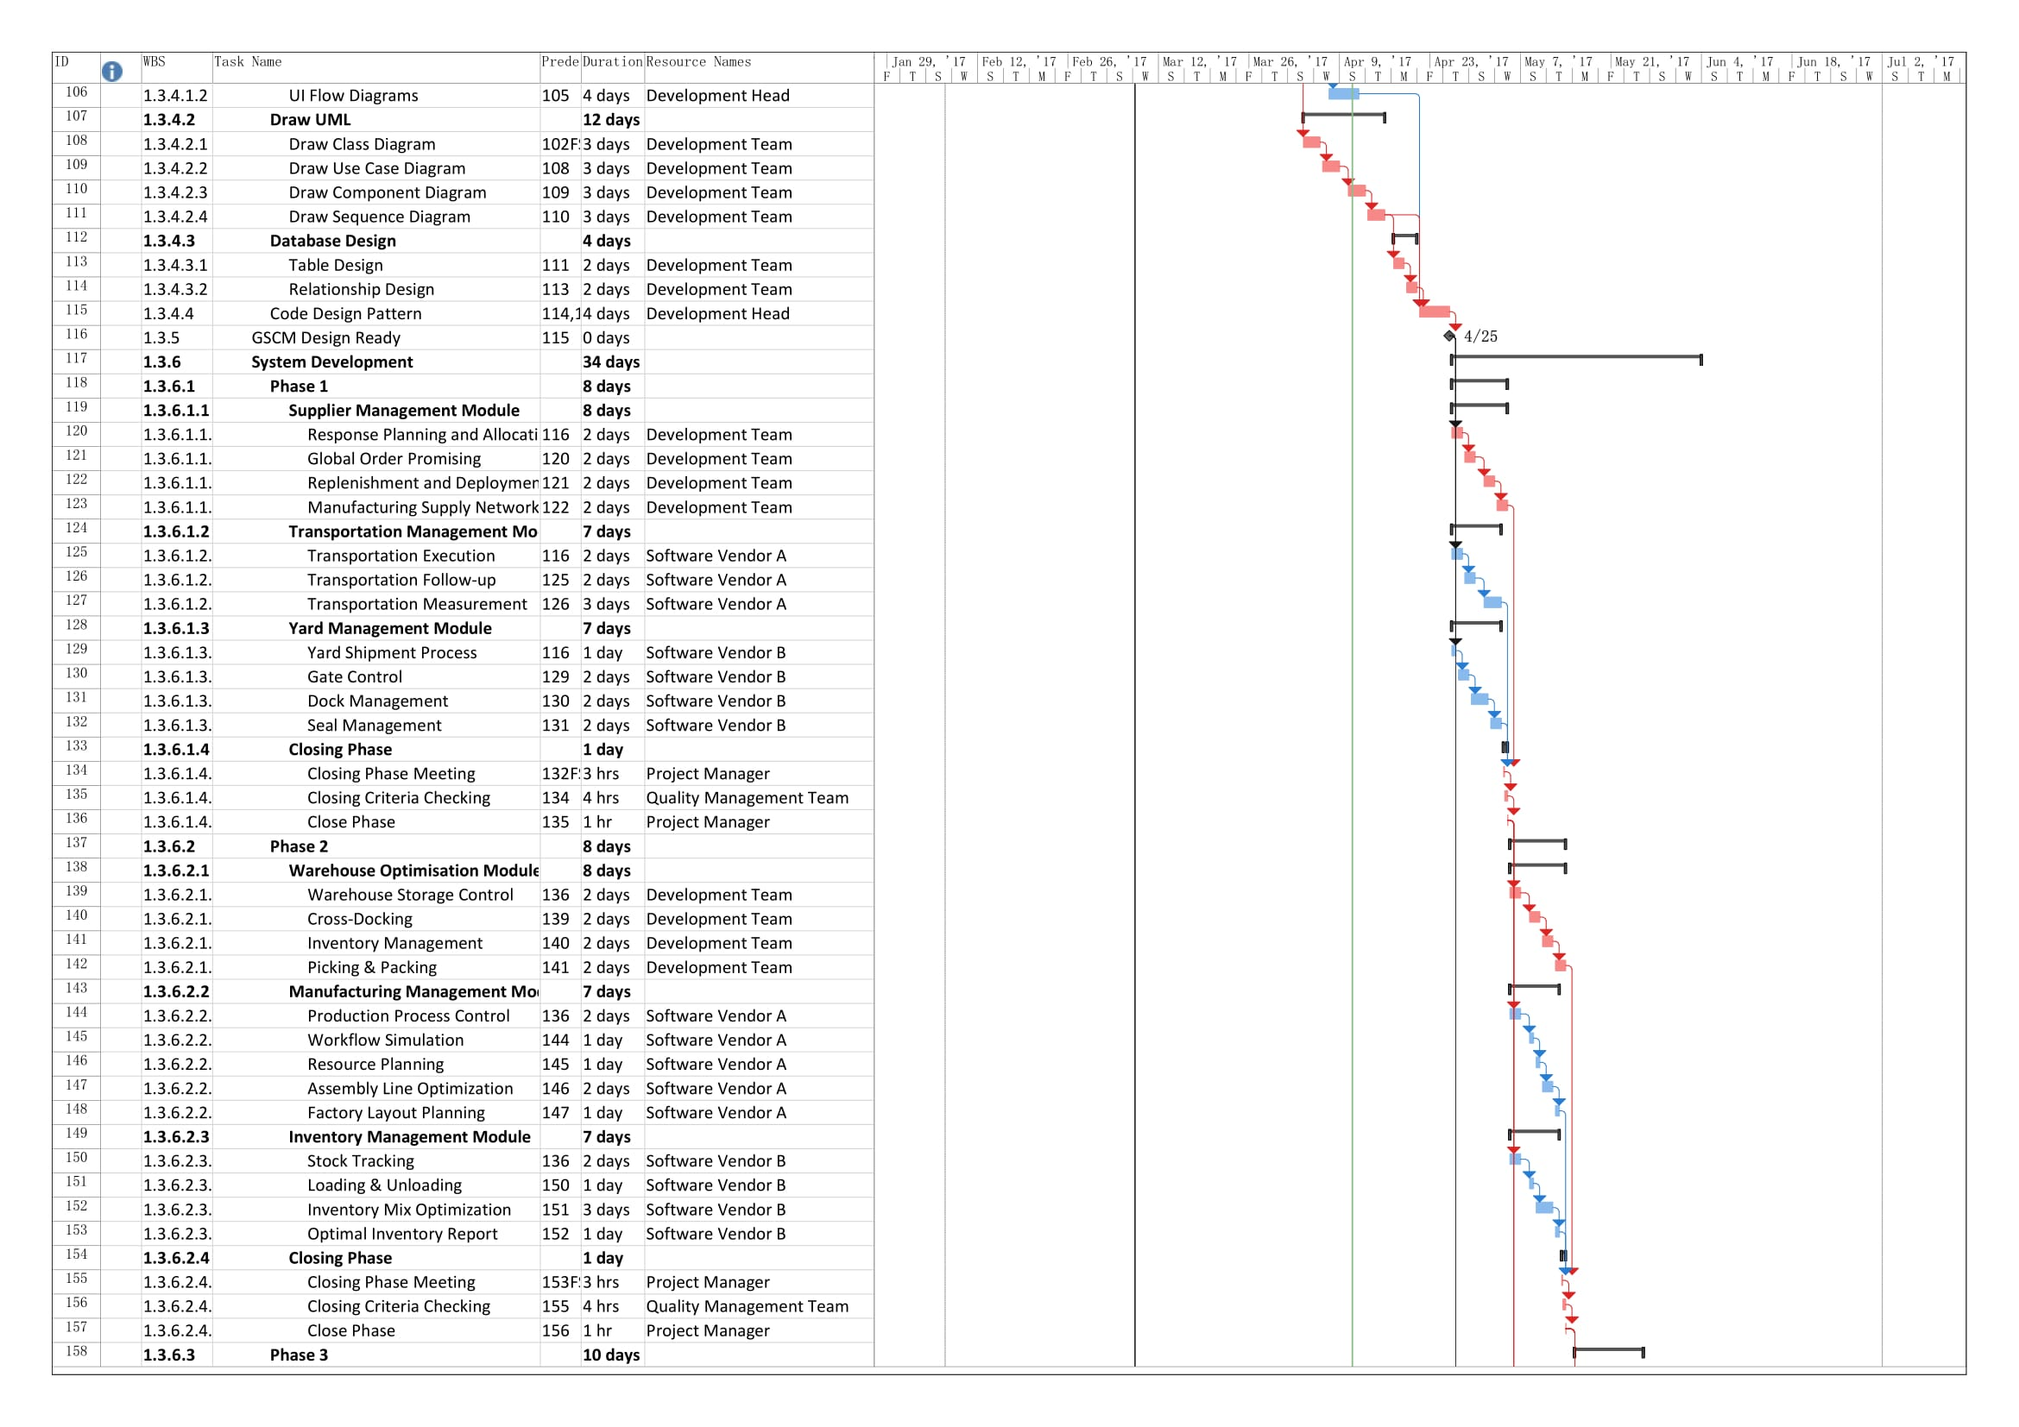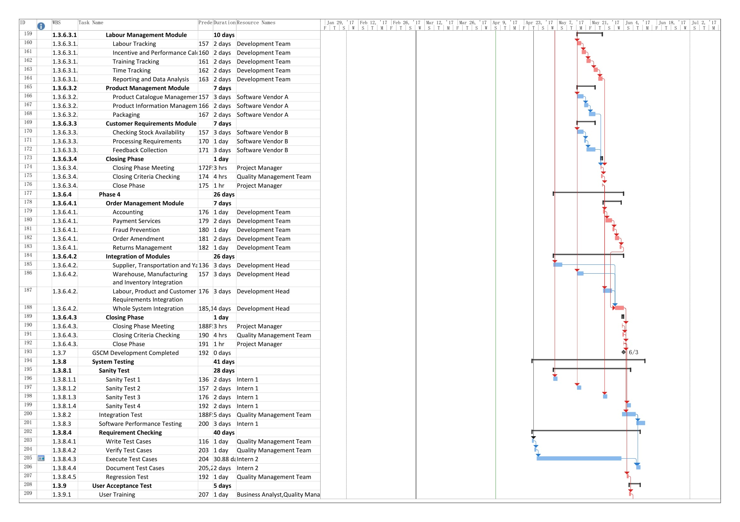

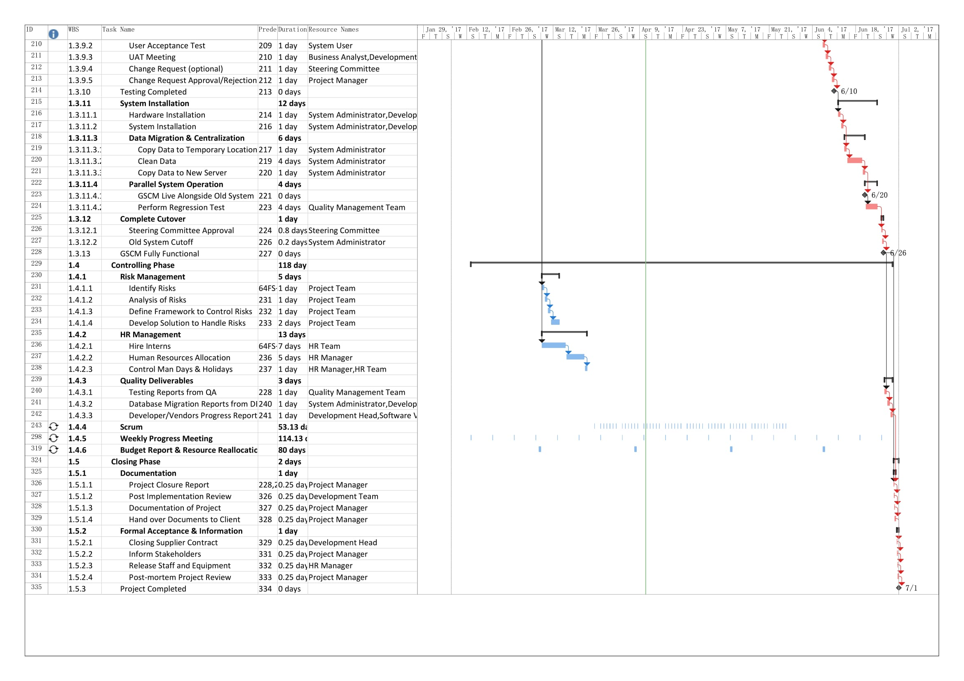

# Network Diagram

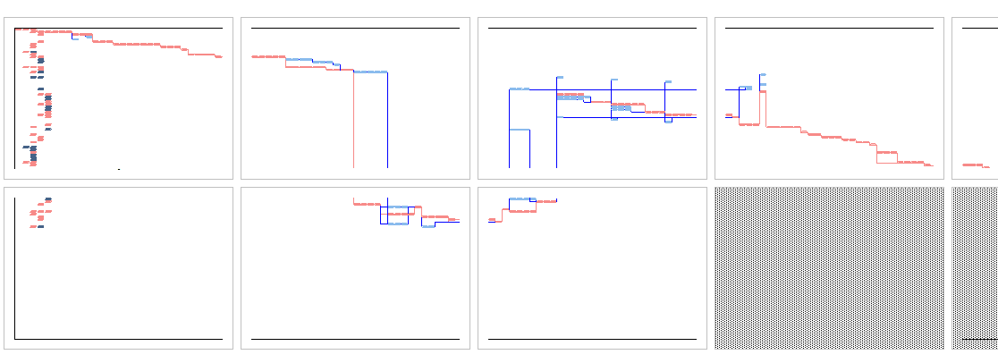

# Cost Budgeting

|  |  |  |
| --- | --- | --- |
| WBS | Task Name | Cost |
| **1** | **GSCMP** | **$251,063.25** |
| **1.1** | **Initiation Phase** | **$9,730.00** |
| 1.1.1 | Project Start | $0.00 |
| **1.1.2** | **Evaluation & Recommendation** | **$8,230.00** |
| **1.1.3** | **Develop Project Charter** | **$1,000.00** |
| **1.1.4** | **Project Charter Approval** | **$500.00** |
| 1.1.5 | Project Approved | $0.00 |
| **1.2** | **Planning Phase** | **$11,800.00** |
| **1.2.1** | **Create Scope Statement** | **$1,000.00** |
| **1.2.2** | **Determine Project Team** | **$800.00** |
| **1.2.3** | **Project Planning** | **$10,000.00** |
| **1.3** | **Execution Phase** | **$202,883.25** |
| **1.3.1** | **User Requirement Specification** | **$13,000.00** |
| **1.3.2** | **Procurement** | **$43,928.25** |
| **1.3.3** | **Task/Module Breakdown** | **$4,200.00** |
| 1.3.3.1 | Supplier Management Module | $800.00 |
| 1.3.3.2 | Transportation Management Module | $0.00 |
| 1.3.3.3 | Yard Management Module | $0.00 |
| 1.3.3.4 | Warehouse Optimisation Module | $800.00 |
| 1.3.3.5 | Manufacturing Management Module | $0.00 |
| 1.3.3.6 | Inventory Management Module | $0.00 |
| 1.3.3.7 | Labour Management Module | $800.00 |
| 1.3.3.8 | Product Management Module | $0.00 |
| 1.3.3.9 | Customer Requirements Module | $0.00 |
| 1.3.3.10 | Order Management Module | $800.00 |
| 1.3.3.11 | Kanban Tasks Listing with JIRA | $1,000.00 |
| **1.3.4** | **System Design** | **$22,400.00** |
| 1.3.5 | GSCM Design Ready | $0.00 |
| **1.3.6** | **System Development** | **$100,400.00** |
| **1.3.6.1** | **Phase 1** | **$27,300.00** |
| **1.3.6.1.1** | **Supplier Management Module** | **$6,400.00** |
| **1.3.6.1.2** | **Transportation Management Module** | **$10,000.00** |
| **1.3.6.1.3** | **Yard Management Module** | **$10,000.00** |
| **1.3.6.1.4** | **Closing Phase** | **$900.00** |
| **1.3.6.2** | **Phase 2** | **$27,300.00** |
| **1.3.6.2.1** | **Warehouse Optimisation Module** | **$6,400.00** |
| **1.3.6.2.2** | **Manufacturing Management Module** | **$10,000.00** |
| **1.3.6.2.3** | **Inventory Management Module** | **$10,000.00** |
| **1.3.6.2.4** | **Closing Phase** | **$900.00** |
| **1.3.6.3** | **Phase 3** | **$28,900.00** |
| **1.3.6.3.1** | **Labour Management Module** | **$8,000.00** |
| **1.3.6.3.2** | **Product Management Module** | **$10,000.00** |
| **1.3.6.3.3** | **Customer Requirements Module** | **$10,000.00** |
| **1.3.6.3.4** | **Closing Phase** | **$900.00** |
| **1.3.6.4** | **Phase 4** | **$16,900.00** |
| **1.3.6.4.1** | **Order Management Module** | **$5,600.00** |
| **1.3.6.4.2** | **Integration of Modules** | **$10,400.00** |
| **1.3.6.4.3** | **Closing Phase** | **$900.00** |
| 1.3.7 | GSCM Development Completed | $0.00 |
| **1.3.8** | **System Testing** | **$8,155.00** |
| **1.3.9** | **User Acceptance Test** | **$6,000.00** |
| 1.3.10 | Testing Completed | $0.00 |
| **1.3.11** | **System Installation** | **$4,800.00** |
| **1.3.12** | **Complete Cutover** | **$0.00** |
| 1.3.13 | GSCM Fully Functional | $0.00 |
| **1.4** | **Controlling Phase** | **$24,800.00** |
| **1.4.1** | **Risk Management** | **$4,000.00** |
| **1.4.2** | **HR Management** | **$11,200.00** |
| **1.4.3** | **Quality Deliverables** | **$2,400.00** |
| **1.4.4** | **Scrum** | **$0.00** |
| **1.4.5** | **Weekly Progress Meeting** | **$0.00** |
| **1.4.6** | **Budget Report & Resource Reallocation** | **$7,200.00** |
| **1.5** | **Closing Phase** | **$1,850.00** |
| **1.5.1** | **Documentation** | **$950.00** |
| **1.5.2** | **Formal Acceptance & Information** | **$900.00** |
| 1.5.3 | Project Completed | $0.00 |

# Quality Management

Quality management within the context of a project involves creating policies and procedures to ensure the product – GSCM is delivered with the expected quality. It also ensures that both the project and product requirements are met and validated (Project Management Institute, 2013). This is achieved in three distinct phases that will be detailed in the upcoming sections.

## Planning

The first step in quality management is planning. In this stage, quality requirements and standards are defined for the whole project. The planning considers the scope, schedule, cost, and risks to produce a quality management plan. This serves as a benchmark for all work produced by the project and so that they meet the specified quality criterion (Project Management Institute, 2013).

To facilitate the production of this plan, several tools and techniques can be utilized. Performing a cost-benefit analysis can highlight activities which are utilizing too much money and find areas where savings can be made. The design of experiments technique can also be used to locate factors that influence the product in production (ODwyer & McDonough, 2011). It serves to optimize products and processes, improving its performance. The design of inspection and test plans (ITP) is also crucial as it serves as a systematic means of testing a product or system (Mande, 2013). In the case of the GSCM project, a development test plan will be used, the result of which will also serve as the quality measurement metric.

Additionally, the quality plan can also utilize general evaluation techniques such as brainstorming, force field analysis, sticking dots and nominal group techniques to make decisions on the details of the quality plan (Project Management Institute, 2013).

## Assurance

Quality assurance is the process of auditing the quality requirements and quality control measurement result to ensure that quality standards are appropriate and provides continuous process improvement (Project Management Institute, 2013).

The quality assurance team may use the tools and techniques of the Plan Quality Management and Control Quality Management such as affinity diagram, which is similar with mind mapping technique used to generate ideas, and prioritization matrices, which is used to prioritize the key issues with its suitable alternatives. In the case of GSCMP, affinity diagrams and prioritization matrices will be used with the development test plan created in quality management planning.

Quality audit is an independent process to determine the compliant of project activities with the project policies (Project Management Institute, 2013). Objectives of quality audit may include identification of good practices being implemented, share good practices applied in previous projects and aid the project team. In the case of GSCMP, quality audit process should proactively aid the project team to improve implementation process as the project duration has been shortened and share good implementation practices with the project development team to improve their productivity.

At the end of the process, change requests may be created based on the result of quality management control and result tools and provide updates on project management plan and organization process assets.

## Control

After the deliverables of the project have been produced, the control quality activities will be performed according to the quality management plan to verify the quality of deliverables are up to standards and meeting the requirements set by stakeholders (Ishikawa, 1990). This process is useful to assess the quality of the deliverables as well as identify the issues and its roots, so that actions can be taken to solve them.

During this process, the deliverables will be inspected and analysed using statistical sampling and basic quality tools. Check sheet, one of the seven basic quality tools can be used to collect data and identify problem areas. The 5 main uses of check sheet are listed as follows (Ishikawa, 1992):

* Check the shape of the probability distribution of a process
* Quantify defects by type
* Quantify defects by location
* Quantify defects by cause
* Keep track of the completion of steps in a multistep procedure (check list)

Usually the data is recorded during unit testing, integration testing or regression testing. Then based on the objectives of the test, one can use different format or type of check sheet to identify the issues or elicit information about the deliverables. The patterns or information acquired from the check sheet can then be used to generate solution to eliminate the issues. Lastly, the system will have to go through user acceptance test to validate whether the deliverables meet stakeholders’ requirements and accepted by them before it can go live. In case changes need to be made, change request will have to be made and reviewed before they can be implemented and the deliverables will have to be retested.

At the end of this process, necessary changes will be made to the deliverables and a verified deliverable will be produced. The results of control quality activities and relevant project documents will also be documented and updated respectively.

# Cutover Strategy and Transition Plan

To ensure the system transition process can be carried out smoothly and minimize the errors which may occur during the cutover period, a plan has been developed for the GSCMP. For this project, parallel cutover has been chosen as the system changeover technique, in which both old and new systems will be running simultaneously while the new system is tested and users are trained.

Running 2 systems simultaneously definitely will be harder besides being more expensive to operate. However, this method reduces the risk significantly by having an old system to fall back to in case of emergency. If the new system is proven to be stable and can replace the old system entirely, the old system will be shut down and substituted.

Before the new system can go live, the new system along with its dependencies such as OS and hardware are first installed. After everything is in place, the data from the old system will then be copied to a temporary location such as backup drives. The data will then be cleaned to ensure the data is not redundant and usable by the new system. Once cleaned, it will then be copied to the new server and used by the new system.

During this period, both old and new system will be running simultaneously. The new system will then be tested for errors and ensure it can run well under heavy load. If it passes the regression test, the project team will seek approval from the steering committee for the permission to end the cutover period and replace the old system entirely. Once approved, the old system will be cut off.

# Lessons Learned

During the project, many lessons were learnt. The ability to create a robust project plan, taking into consideration all the parties involved was an invaluable experience. Furthermore, each team member could obtain more in-depth knowledge in their respective individual sections and learn to create plans adhering to the constraints of a larger group. Each of the team members got to learn the intricacies of project management first hand and more importantly, how a poor plan can cause a project to fail.

# Project Management Knowledge Areas

## Human Resource – Ngui Tze Ken TP031955

HRM or Human Resource Management is one of the 11 knowledge areas described by the Project Management Body of Knowledge. It is made up of the processes required to ensure the most effective use of people involved in a project including all project stakeholders and team members (Project Management Institute, 2013). There are four main processes of Human Resource Management which are illustrated below and will be further discussed in the upcoming sections:

A well thought out and executed human resources plan is essential to a project’s ultimate success. As it is concerned with all the people involved with the project, it can also be a challenge in and of itself. These people, as their work is directly contributing to the project’s progression, if left unmotivated or overloaded could result in parts of the project being delayed or worse. A human resource management plan which is designed well would take pre-emptive action to prevent resource mismanagement and save costs by acquiring only the people needed for an optimized workload. It would also monitor the status of said people throughout the project and motivate them as necessary for the project’s completion.

### Plan Human Resource Management

The first and arguably most crucial step in human resource management is designing the plan. The plan should establish project roles and responsibilities, project organization charts, and the staffing management plan (Project Management Institute, 2013). This plan should be done as early in the project as possible and should usually be developed in tandem with the project plan in the form of a Gantt chart (Mishra, 2007). A project plan and its human resource plan are tightly intertwined hence the need for both to be simultaneously developed and managed.

Once a list of activities in the project have been determined, a project manager should outline the skills required for said activities’ completion and then work from there. Once those details have been worked out, the following information can be determined:

These decisions are then reviewed, analysing their cost implications, availability of the required resources and their utilization within the project. These analyses are done to ensure that the costs incurred are within the given budget, the resources can be obtained when they are required and a single resource isn’t over utilized within the project respectively.

In the context of GSCM, the resources’ work period, quantity and estimated costs are detailed in the Gantt chart in section 5. Expertise required will include subject matter experts in Supply Chain Management. The activities which will be outsourced are the development and testing of GSCM. Some of the system migration tasks will also be assigned to Healthy Living’s acting system administrator.

As the development and testing phases of GSCM will be outsourced, a hiring strategy will be needed. For this project, software vendors will be contracted for several parts of the development and several aspects of the testing will be assigned to hired interns. The vendors will be acquired through a bidding process while the interns will be reassigned from Healthy Living. The remaining positions such as business analysts and quality assurance will require individual employees which will also require hiring. They will be acquired via job advertisements and from previous project members.

Upon commencing the project, the team will need to be monitored to ensure that they stay motivated throughout the project lifetime. In the GSCM project, this will be facilitated by a third-party team management software known as JIRA. Its purpose is to monitor and control a project team both in terms of time, work and resources. Having the ability to view each team member’s performance as well as work assigned to them allows for a better balancing of work and incentives can be given to well-performing members. The human resources plan, when complete, should be approved by HL’s upper management before being implemented. This plan will include vital details such as each role’s description and responsibilities, the project organization chart and the staffing management plan.

#### Project Organization Chart

A project organization chart is used to depict the hierarchical relationship between the team members of a project (Free-Management-eBooks, 2015). This project will apply a matrix organizational structure, allowing team members to be reassigned to different departments for greater flexibility. It combines the characteristics of both functional and project-based organizational structures (Usmani, 2012). The project organization chart below will represent the hierarchy in this project – GSCM.

#### RACI Chart

A RACI – Responsible Accountable Consulted Informed chart, sometimes known as a RAM – Responsibility Assignment Matrix (Project Management Institute, 2013) shows each team member’s level of involvement with a given task or deliverable (Margaria, 2010). A RACI chart can ensure that no single person is taking on too much responsibility. It will also reduce the potential for miscommunication of responsibility and increase the overall productivity of the team (Doglione, 2016). RACI can even be used with SCRUM, which is one of the project’s methodologies – refer to section 1.2. Below is a simplified RACI chart outlining the major tasks in GSCM and the people who are responsible, accountable, consulted and informed in the respective tasks.

|  |  |  |  |  |  |  |  |  |  |  |  |  |  |  |
| --- | --- | --- | --- | --- | --- | --- | --- | --- | --- | --- | --- | --- | --- | --- |
|  | SC | PM | FM | HRM | BA | DH | PCM | QMT | HRT | SME | DT | SV | PCT | IN |
| Feasibility Studies | - | A, R | - | - | - | - | - | - | - | - | - | - | - | - |
| Project Charter | C | A, R | - | - | - | - | - | - | - | - | - | - | - | - |
| Project Team Acquisition | - | A, R | - | - | - | - | - | - | - | - | - | - | - | - |
| Project Schedule Planning | I | A, R | C | C | - | C | C | C | - | - | - | - | - | - |
| HR Planning | I | C | C | A, R | C | C | C | C | R | - | - | - | - | - |
| Budgeting | I | C | A, R | C | C | - | C | C | - | - | - | - | - | - |
| Requirement Specification | C | I | - | - | R | A | - | C | - | R | R | - | - | - |
| Hardware & Software Procurement | - | I | C | - | - | C | A, R | - | - | - | - | - | R | - |
| Vendor Procurement | - | I | C | C | - | C | A, R | - | - | - | - | - | R | - |
| System Design | - | I | - | - | C | A | - | C | - | - | R | - | - | - |
| System Development | - | I | - | - | C | A, R | - | C | - | - | R | R | - | - |
| System Testing | - | I | - | - | - | C | - | A, R | - | - | C | R | - | R |
| System Deployment | I | C | - | - | C | A, R | C | C | - | - | R | - | - | - |
| Documentation | I | A, R | C | C | - | C | C | C | - | - | - | - | - | - |

Note: refer to next page for the RACI code reference

|  |  |
| --- | --- |
| Code | Role |
| SC | Steering Committee |
| PM | Project Manager |
| FM | Finance Manager |
| HRM | Human Resources Manager |
| BA | Business Analyst |
| DH | Development Head |
| HRT | Human Resources Team |
| SME | Supply Chain Management SME |
| DT | Development Team |
| SV | Software Vendors |
| QMT | Quality Assurance Team |
| PCM | Procurement Manager |
| PCT | Procurement Team |
| IN | Interns |

|  |  |
| --- | --- |
| Code | Meaning |
| R | Responsible for the task |
| A | Accountable to the task (limited to one person) |
| C | Consulted for input regarding task |
| I | Informed on task changes |

#### Resource Histogram

A resource histogram is used by a project management team to provide a visual representation of the resource allocation throughout the project’s lifetime to all parties that are interested. It is often depicted as a bar chart of resource usage units against time (Project Management Institute, 2013). Below are three resource histograms created for this GSCM project:

#### Staffing Management Plan

Upon completing the human resources planning, the staffing management plan is one of the documents that will be produced. This document will include all the details relating to staff including the acquisition methods, staff skill levels, performance review plans and release plans. It should also include the staff resource histogram to show each employee’s utilization in a month (Piscopo, 2017). An example of a staffing management plan is attached in appendix A.

#### Motivational Theory

In any project team, the use of motivational techniques is important in keeping a team productive. The basic idea of motivation is that people will do things to satisfy their needs and avoid doing things that are dissatisfying. Before being able to meet needs of the project team members of GSCM, one must first identify said needs. There are several models that project this such as Hertzberg’s Two-Factor Theory, Expectancy Theory and Maslow’s Hierarchy of Needs (Mark, 2014). The expectancy theory focuses on three main concepts: valence, expectancy and instrumentality. However, this theory won’t be utilized during the GSCM project.

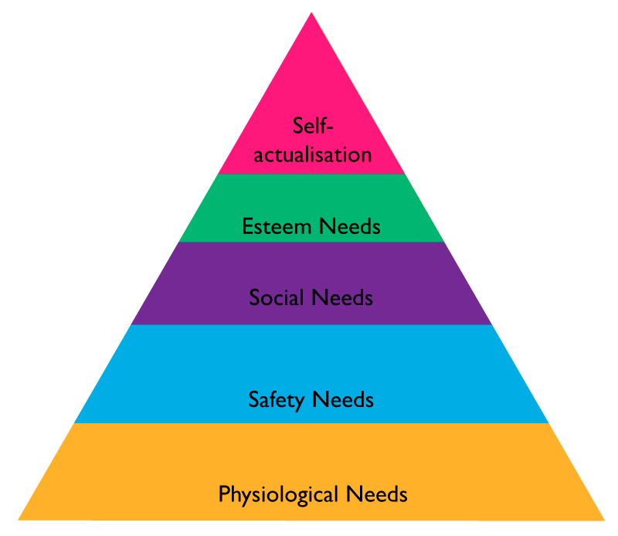Arguably the most popular theory is Maslow’s Hierarchy of Needs. The pyramid to the right shows the various levels of needs experienced by people with physiological needs being the most basic of needs. This theory states that the first four levels are considered deprivation needs. Without which, a person cannot function at their optimum (K., 2014). Meeting these needs will be of utmost importance when developing the GSCM project team before moving on to the other levels.

Once that is achieved, the self-actualization level can be tackled. As it is a rather abstract concept for an employee to understand. Chip Conley, the head of hospitality at Airbnb found a way to help employees realize the importance of their job. By providing a situation where employees had to view their jobs from a unique perspective, it allowed them to feel respected and motivated to work harder (Pattison, 2010).

The Two-Factor theory will also be used in the GSCM project. It says there are two main types of motivation that can be applied: intrinsic and extrinsic motivation (Boundless, 2016). Intrinsic motivation causes a person to work for their own enjoyment while extrinsic motivation causes a person to do something for a reward or avoid a penalty (Ryan, et al., 2000). A combination of both will be used in the GSCM project.

### Acquire Project Team

Project team acquisition is usually the first thing to be done after the project plan is complete. The HR plan begins execution by acquiring the required human resources for the project. Staff that are to be hired need to be selected according based on having the appropriate skills, experience, availability as needed by the project schedule, and fit the budget allocated (Mishra, 2007). Project team acquisition goes through several key stages:

#### Negotiation Techniques

Negotiation is a skill required of project managers during staff acquisition as they will need to negotiate with many parties to ensure the project’s resource requirements are met. There are several techniques to keep in mind while conducting a negotiation to ensure success. Among the most important of these techniques is having confidence and preparation. Being confident and hiding one’s desperation won’t allow the other party to have leverage. Preparation can also give one the upper hand in a negotiation and should always be done beforehand (Bisk, 2017).

In GSCMP, negotiation needs to be done with the staff as they will need to work on Saturdays. Negotiation with the functional managers to ensure the required staff are hired within budget is also needed. The project manager will also need to negotiate with the Healthy Living management to obtain the staff needed such as the system administrator and interns without additional pay.

#### Acquisition Techniques

For the GSCM project, a large majority of the team members are already available. The HR manager, finance manager, development head, procurement manager and quality assurance head will all be acquired from previous projects as they are all available for this project. This practice is known as pre-assignment. The business analyst was unavailable for the project duration and hence will need to be acquired. The subject matter expert will need to be acquired as well. Also, some of the development team from previous projects are unavailable so new ones will be hired. Lastly, several interns already in Healthy Living and can be reassigned to the project.

For both the business analyst, subject matter expert and development team members, they will be acquired through Healthy Living’s database of previous applicants. This is chosen over a traditional job posting because it would be much faster than a job posting and the project needs to begin as soon as possible. Using their existing database of job applications, criteria can be set to find suitable applicants. A database search would be advantageous in this situation as it can be done relatively quickly (ClearFit, 2012) and Healthy Living being a global company already stores said information in their existing enterprise resource planning system.

### Develop Project Team

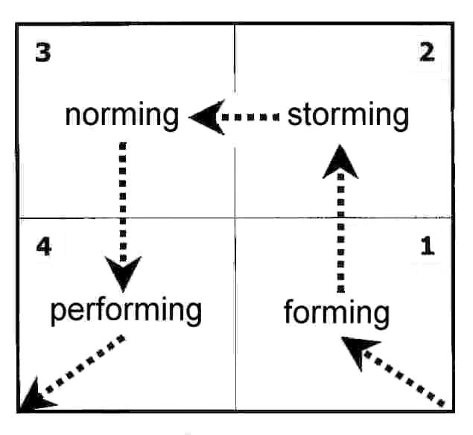With the project team now on board, they must be developed to ensure they function well together. This is to improve their competencies and interaction with each other, thereby enhancing everyone’s overall performance (Project Management Institute, 2013). Under the Tuckman Model, each team member experiences four stages of team development as shown on the right. A fifth stage, “adjourning” also occurs after the project is complete and team members are released (Chapman, 2013).

#### Team-Building

Team building is a well-known technique for developing a team. The reason being that it is easy to do and will yield positive moderate results across all types of teams (Klein, et al., 2009). In GSCM, this will be done during the project kick-off meeting, and during the Scrum sprint planning meetings. During these team-building sessions, ice breakers and a short game such as Two Truths and a Lie can be held. The Scrum master will oversee these team-building activities. These activities can go a long way in building trust and communication between new team members as well as hone their interpersonal skills (Huddle, 2016).

#### Recognition and Rewards

By recognizing and rewarding performing team members, they can be motivated to do even better. There are many methods of rewarding a team member, all of which should take into consideration a motivational theory such as Maslow’s Hierarchy of Needs described in section 11.1.1.5. In the context of GSCM, using plugins for Jira software, a gamification scheme can be implemented with real-world rewards such as bonuses and increments (Luxoft, 2017). At every project milestone, a celebratory party will also be held to recognize the team’s combined efforts. This will provide both intrinsic and extrinsic motivation to the team members.

#### Assessment Tools

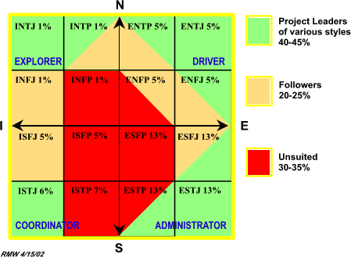Employees will be given a MBTI test to find their personality type to decide if they are suitable for the position. The MBTI test categorizes people into 16 different personality types, each with varying suitability in various aspects of project management (The Myers & Briggs Foundation, 2017). There are some which are more suited for project followers and leaders (Wideman, R. Max & Aaron J. Shenhar, 2002).

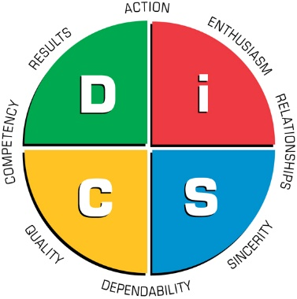During the interview, a DISC assessment will also be given to evaluate their behaviour under different situations. The DISC profile evaluates a person based on four criteria, Dominance, Influence, Steadiness and Compliance. Below is a table of what the tests look to find in the acquired GSCM staff. These influence the decision, but ultimately qualification weighs more than personality.

|  |  |  |
| --- | --- | --- |
|  | MBTI | DISC |
| Business Analyst | INTP | High D, C and S |
| Subject Matter Expert | ENTP | High D and C |
| Development Team | INFJ | High D and I |

### Manage Project Team

The last phase of HRM per the PMBOK (Project Management Institute, 2013) is managing the project team. This includes evaluating performance, providing feedback, resolving problems and optimizing team structures. Two of the most important tasks in successfully managing a project team is performance measurement and conflict management. These will both be applied in the context of the GSCM project.

#### Performance Measurement

The act of performance measurement is important in ensuring all the team members are working at their optimum. This can be done in multiple ways such as observation, talking to members or using a KPI. The former two can be a good indicator of a team member’s current state, but is a relatively subjective means of measurement. Using a KPI will give more objective measurement that can determine the gap between actual and targeted performance (Balanced Scorecard Institute, 2017).

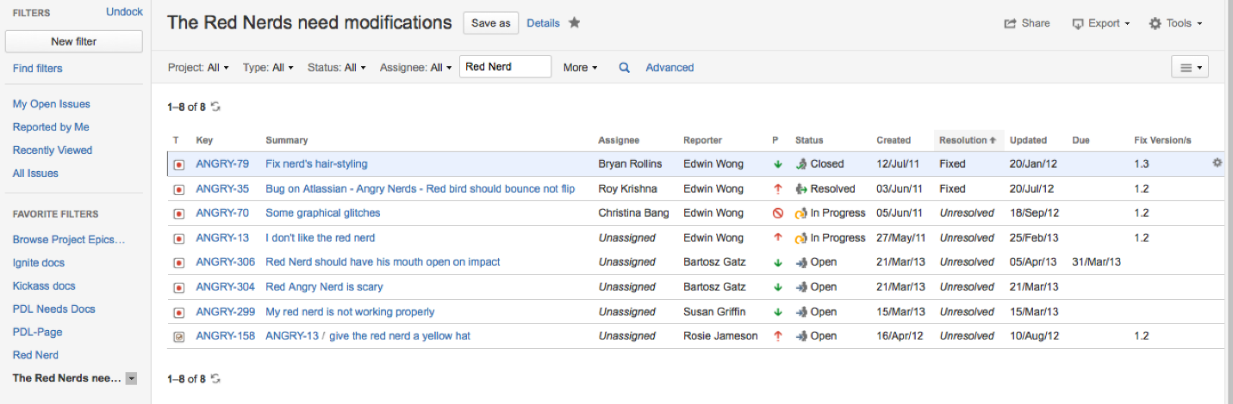

As the GSCM project will be using JIRA for project management and all tasks and activities will be logged and assigned through it, performance can easily be measured (Atlassian, 2017). Using the interface, like the one shown above, an employee’s performance can be measured using the due date of a task against the actual completion time. With JIRA, manually written progress reports can be omitted as it can be automatically generated.

#### Conflict Management

In a setting involving more than one person such as in the GSCM project team, conflicts in interest, goals or values may arise (HumanMetrics Inc.). The likelihood of it happening only increases with more people, hence it is important that it is managed well so it doesn’t become a hindrance to productivity. Successful handling of conflicts can lead to increased team coherence and productivity as the parties involved will be able to understand each other’s perspectives and/or respect their point of view. Resolving conflicts can be done using five general techniques. The figure below depicts each technique and its use (Dontigney, 2011).

#### Influence of Power

The use of power in managing a team is also an important concept to understand. In the GSCM project, the influence obtained from a position such as project manager or departmental head should be properly utilized. As noted by the French and Raven theory, there are five types of influential powers which are separated into two main categories (Vliet, 2014). Below is a table explaining them.

|  |  |  |  |
| --- | --- | --- | --- |
| Power | | Explanation | Usage Situations |
| Positional | Coercive | Forcing someone to do something against their will. This is done using threats like putting someone’s job or reputation on the line. | In high pressure situations where failure isn’t an option or when a person is consistently underperforming. |
| Reward | Rewarding subordinates for completing tasks. Can be in the form of bonuses, promotions and so on. | For tasks in general or to get a person to do work not originally assigned to them. |
| Legitimate | Using positional influence and employees’ notion of responsibility to their leaders. | Can be used for project management situations to keep subordinates motivated and productive. |
| Personal | Expert | Based on one’s knowledge or expertise in specific areas. Others will trust the decisions made by someone proven more informed. | As an employee or subject matter expert, this is useful to get people to trust and accept leadership. |
| Referent | Power from being charismatic or treated with high regard. Usually a result of being relatable to others. | Used when meeting new people and building trust with team members. |

### Conclusion

Human Resource Management is an essential cornerstone within the project’s lifetime. Because people are the driving force behind a project’s success, it is important for human resources to be done correctly. The plan which was concocted for the GSCM project has shown that many steps need to be done to ensure a good human resource plan is in place. From planning to acquiring, developing and managing, each phase requires keen attention to detail. With all that has been done, many lessons have been learnt such as acquisition and motivational techniques.

## Communication – Hua Chye Yee TP032037

Communication, a process where information is exchanged is commonly used in our daily lives to deliver message, share ideas and express emotions. However, it can be difficult for some people to communicate under certain situations because the process can get rather complicated and difficult especially when people with diverse cultural background, education and languages are involved.

Due to our differences, communication can be ineffective at times or worse, lack of communication between the parties. This may result in problems such as misunderstanding or causing others to overlook some critical issues. Some of these consequences can be very costly especially in the case of project management as failing to communicate effectively can have negative impact on the project or even cause the project to fail. This is because communication is an integral part of project management, since the project manager must spend roughly 80% of his or her time communicating with the project team members as well as the stakeholders over the course of the project (Nogueira, 2017). Thus, it can be said that effective communication is the key to a successfully project management. The latest Pulse of the Profession report by PMI solidifies that claim because it has been revealed that inadequate and poor communication are one of the top 5 factors for causing a project to fail (Project Management Institute, 2017). This clearly shows that effective communication is indeed important and all project managers should manage the communication in project properly.

Effective communication can be facilitated through project communications management, which contains 3 main processes, namely plan communication management, manage communication and control communication. These processes can ensure the appropriate project information can be collected, stored, distributed and generated timely (Usmani, 2012).

|  |  |  |  |
| --- | --- | --- | --- |
| Process | Inputs | Tools & Techniques | Outputs |
| Plan Communications Management | * Project management plan * Stakeholder register * Enterprise environmental factors * Organizational process assets | * Communication requirements analysis * Communication technologies * Communication models * Communication methods * Meetings | * Communications management plan * Project documents updates |
| Manage Communications | * Communications management plan * Work performance reports * Enterprise environmental factors * Organizational process assets | * Communication technology * Communication models * Communication methods * Information management systems * Performance reporting | * Project communications * Project management plan updates * Project documents updates * Organizational process asset updates |
| Control Communications | * Project management plan * Project communications * Issue log * Organizational process assets | * Information management systems * Expert judgment * Meetings | * Work performance information * Change requests * Project management plan updates * Organizational process asset updates |

### Plan Communication Management

The very first process in project communication management is to develop a project communication plan that describes how project communication will be planned, structured, monitored and controlled (Goudar, 2010). This process and plan will impact the success of a project greatly, or in this case GSCMP as they serve as the foundation for communication management and thus must be done properly.

This process requires several information and documents from the organization as well as the project, for instance the project management plan and stakeholder register. Additionally, the enterprise environmental factors and organizational process assets will also need to be known as they will influence the output of this process. This information will then be used to determine how the communication should take place and who should receive what kind of information.

Communication requirements analysis will be one of the techniques used to determine the information needed by the project stakeholders, along with the type and format of information. Additionally, meetings will be used to determine the most appropriate way to update and communicate project information. Technology, model and methods of communication will also be determined in this section.

The output of this process will be none other than the communication management plan. Several project documents such ass project schedule and stakeholder register will also be updated and modified because of this process.

#### Communication Requirement Analysis

|  |  |  |  |  |  |  |
| --- | --- | --- | --- | --- | --- | --- |
| Stakeholder | Importance (of them) | Level of support (given by them) | Expectation from stakeholder | What’s important to stakeholder | How could stakeholder block the project | Strategy for enhancing stakeholder support |
| Project Manager | High | High | Progress report  Forecast report  Project management plan | Success of the project | Coordinate the team poorly or repeat the same mistakes as previous project manager | Weekly meeting, monthly teambuilding and celebration at all milestones |
| Human Resource Manager | Medium | Medium | Resource calendar | Hire right person to fill in the job position | Ignore the conflicts happened among the project team |
| Procurement Manager | Medium | High | Task allocation  Budget allocation | Contract with vendors and acquire necessary hardware and software for the project successfully | Procure without doing proper tendering process, bias when awarding contract to vendor or fail to find vendors, software and hardware for the project |
| Software Vendors | High | High | Task assignments  Resource calendar  Issue log | Deliver the deliverables timely while meeting the requirements given | Delay the delivery of deliverables or fail to meet the requirements given |
| Interns | Low | High | Test plan | Test system and discover as many issues as possible | Not testing the system thoroughly or not failing to report the issues to developers |
| Development Team | High | High | Task assignments  Resource calendar  Issue log | Deliver the deliverables timely while meeting the requirements given | Delay the delivery of deliverables or fail to meet the requirements given |
| System Administrator | High | Medium | Cutover plan | Success of cutover | Failing to follow the cutover plan properly |
| Steering Committee | High | High | Status report | Success of the project | Refuse to cooperate or dissatisfy with the project progress or its deliverables |
| System User | Medium | Medium | User manual | Ensuring the system can meet their standards in production environment | Providing negative feedback during user acceptance test |

#### Communication Medium

Communication requires at least a medium to be accomplished as the message has to rely on some sorts of tools or techniques to pass around. The communication medium, also known as communication channel can maximize the effectiveness of communication if used correctly in appropriate situations. Basically, communication medium can exist in the form of formal written, formal verbal, informal verbal and non-verbal.

|  |  |
| --- | --- |
| Communication Medium | Example |
| Formal Written | RFP, Project Charter, Documents |
| Formal Verbal | Speech, meeting, presentation |
| Informal Verbal | Casual discussion |
| Non-verbal | Body language, gesture |

Generally, formal communication is best used when the information exchanged is required to be recorded in case of future reference. For instance, formal written documents like progress report and letters can effectively pass the information to the recipients while acting as storage to record the information. Such medium is also appropriate for the case where the sender is required to follow established professional rules, standards and processes when delivering the message (BusinessDictionary, n.d.). For example, meeting and presentation should be used if there is a need to discuss or present information professionally with the steering committee.

On the other hand, if the information exchanged is not important and does not necessarily need to be recorded, informal verbal would be the most appropriate option. Discussion among the peers and table talk fall under this category. Non-verbal such as the use of body language and gesture can be used along with the mentioned communication mediums, especially verbal communication as it helps to emphasize important points besides can be used to capture and keep the audience’s attention.

In short, factors like situation, audience, nature and type of message should be considered when choosing the communication medium as it helps to maximize the effectiveness of communication.

#### Communication Model

|  |  |
| --- | --- |
| Elements | Description |
| Sender | Person who initiates and distributes the message |
| Receiver | Person who gets the message |
| Message | An information |
| Medium | Communication channel or things used to transmit the message |
| Feedback | Response to message |
| Noise | Something that interferes the message |
| Encode | Construct or form a message so it can be sent |
| Decode | Interpret the encoded message |

For a communication to work, at least 2 parties will be needed, which are the sender and receiver. A message is then encoded by the sender and sends through a medium. When constructing the message, the sender is responsible to make sure the message formed is clear and complete so it can be understood easily by the receiver.

When delivering the message, it may be interfered by noise and might compromise the delivery of the message. Thus, interference like background noise and distance should be considered and minimized before sending the message to ensure the message can reach the receiver.

After the message is received by the receiver, the message is then decoded by them. The receiver has the responsibility to understand the message properly. Depends on the situation, they may have to acknowledge the message is received or even respond to the message by providing feedback.

#### Communication Technology

Technology-mediated communications can be very useful as it is faster, more reliable and can convey message in a large variety of formats when compared to face-to-face communication. However, choosing the right tool or application can be difficult since there is a plethora of communication technologies available on the market right now. The following factors should be considered when determining the right communication technology for a given situation (Project Management Institute, 2013):

* Urgency of the need for information
* Available of technology
* Ease of use
* Project environment
* Sensitivity and confidentiality of the information

In the case of GSCMP, majority of the communications will be done using company’s email system, JIRA, Slack and WhatsApp. Email will be mostly used in vertical communication, where the conversation or information is required to be recorded. For instance, notify and update the project team members or stakeholders that there is a meeting, update of project status or when making enquiries. JIRA, an issue and project tracking tool will be used extensively by the development team to track and update the project status. Communication within the project team will mainly be done using Slack, a cloud-based team collaboration tool. Video conference using Skype Meetings will be used in case one or more participants could not physically able to attend an important discussion or meeting. Phone call, SMS and instant messaging app will only be used if someone could not be contacted using the above methods or the message is extremely urgent and need to be delivered instantly.

|  |  |
| --- | --- |
| Communication Technologies | Platform |
| Email | Company email system, Microsoft Outlook |
| Issue and project tracker | JIRA |
| Cloud-based team collaboration tool | Slack |
| Video conference | Skype Meetings |
| Cellular communication | Phone call, SMS |
| Instant messaging | WhatsApp |

#### Communication Methods

Information sharing can be done in numerous ways and each comes with their own pros and cons. These communication methods can be classified into interactive, push communication and pull communication.

Interactive communication, as its name suggested involves multiple parties performing a multidirectional exchange of information (Project Management Institute, 2013). This method is highly effective as it requires involvement from all parties. Due to the nature of this method, it is often used for key information finding. A notable example of this communication method would be discussion, where all participants need to understand the topic and voice out their opinions before concluding.

Push communication is a passive communication method where the information is sent to recipients who requested for it. This method of communication can ensure the information is distributed but does not guarantees the information will reach or understand by the recipients. Email, SMS and faxes are examples of push communication.

In contrast, pull communication requires the recipients to access the information at their own will. This method can be used to deliver detailed information to large audience. For example, project progress on JIRA. However, it is possible for the audience to miss the posted information as they may choose to ignore it or simply unaware the existence of such information.

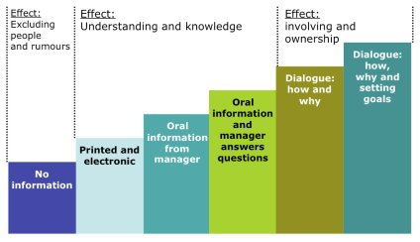To determine which method should be used for a given situation, one can use Ambition Stairway. This tool will recommend a communication medium and method based on the sender’s level of ambition (The Communication Toolbox, 2008). For instance, push and pull communications would be the appropriate method if the goal is just to pass knowledge or information to audience. On the other hand, interactive communication would be more appropriate if the goal is to get the audience involved.

Diagram : The Ambition Stairway detailing which communication method should be used based on the ambition or intention of the sender

#### Information Sensitivity

Sensitive and confidential information may be given by HL, discovered or generated throughout the lifetime of GSCMP. This information generally concerns about the privacy or security of the company or project, which will impact the project, project team and HL negatively if shared with third-party organizations or public. For instance, trade secrets, supplier and finance information, company’s proprietary technology and upcoming product line-up.

To safeguard the sensitive information, they should be kept internally and may only be accessed by authorized person. Assume that someone wishes to access sensitive and confidential information, he or she should request permission from the head of department, project manager or steering committee depends on the scope of information. For instance, if the information concerns about HL such as their financial information, the steering committee should authorize the access. Project related information like program source code however, should be authorized by both the project manager and development head instead. Albeit project manager is given the authority to share the information, project manager still must comply with HL’s policy when sharing the information to ensure the information shared will not damage the organization or project in any way.

To further protect and secure this information from unauthorized access, several good practices, policies and security measures should also be set (Stevens, 2016). These measures include but not limited to:

* Create security expectations for vendors
* Don’t allow vendor access to data without doing proper assessment
* Use only approved, clean devices or network to share data
* Ensure the project team and stakeholders are aware of confidentiality obligations

While sensitive information should not be shared freely, certain high-level information can be shared in certain cases such as they are needed by the project team or vendors to achieve the objectives. For example, product details and supplier information are needed to complete supplier management module and product management module. However, confidentiality agreement should be signed and monitoring should be done continuously to prevent misuse or leak of information.

Public information on the other hand can be shared freely as they are non-sensitive in nature such as marketing materials. However, such information should only be shared given that it is informative and only it has been confirmed to be true as well as ready to be revealed.

#### Communication Roles and Responsibilities

|  |  |
| --- | --- |
| Role | Responsibilities |
| Project Manager | * Communicate with stakeholders, project team and vendors * Coordinate the project team * Monitor project progress * Assess and review project team performance * Plan and maintain project documents * Provide status report to the steering committee |
| Project Team | * Provide progress report to project manager * Read communications and perform tasks accordingly |
| Human Resource Manager | * Coordinate human resource team |
| Human Resource Team | * Assess employees’ qualification * Communicate valuable information among employees |
| Procurement Manager | * Communicate with potential vendors * Coordinate procurement team |
| Procurement Team | * Communicate and collaborate with project manager to make decision on procurement items specification |
| Finance Manager | * Manage and approve budget * Report financial status to project manager |
| Business Analyst | * Analyse and document business domain * Provide project team and developer team information regarding the business operation and process of HL |
| Supply Chain Management SME | * Conduct operational feasibility study |
| Software Vendors | * Report the progress of outsourced modules |
| Interns | * Report the bugs and issues to the development team |
| Quality Assurance Team | * Assess and report the quality of the deliverables |
| Development Head | * Coordinate the development team |
| Development Team | * Progress reporting * Bug and issue reporting and tracking |
| System Administrator | * Report the progress and status of cutover |
| Steering Committee | * Provide necessary information to project team * Approve request * Review documents * Conduct user acceptance test meetings |
| System User | * Provide feedback about the system * Report the result of user acceptance test |

#### Communication Management Plan

The communication management plan is the output of plan communication management process and arguably the most important document in communication management. This plan includes the necessary information to guide project communication, allowing the project team to deliver the right information to the right person in the most efficient and effective manner.

Essentially, the plan will contain stakeholder communication requirements, communication matrix, communication vehicles, communication approval process, communication standards, communication analysis, design, evaluation, handling and meeting guidelines for the project. This information will specify the flow, medium, technology, frequency, process, person in charge, audience and objective of the communication. A sample of this template is included in appendix C

If planned and done right, the plan can help to avoid some common problems caused by poor communication such as misunderstanding, communication of information to the wrong audience, insufficient communication, misinterpretation and delay in message delivery.

### Manage Communications

After developing the communication management plan, the plan will be executed over the course of the project. Throughout this process, the project information will be created, collected, distributed, stored and retrieved (Project Management Institute, 2013).

In order for this process to be carried out smoothly, communication management plan and work performance reports are required to guide the project communication and facilitate discussion respectively. This process can be affected by enterprise environmental factors as well as organizational process assets, such as the organizational culture and policies, government or industry standards and regulations.

Throughout this process, previously planned communication technologies, communication models and communication methods will be used to manage and distribute the information. Performance reporting too will be carried out to track and update the stakeholder regarding the status of project.

At the end of this process, project management plan, project documents and organizational process assets will likely be modified and updated as the changes made or work done for the project will have to be reflected in those documents and records.

##### Progress Report

The progress report describes the activities and budget that have been accomplished and incurred respectively over a certain period, usually since the last progress report. The report will be published at a regular interval, usually weekly, bi-weekly or monthly for the project manager or stakeholder to inform them about the progress of the project. With the given information, they can then make better decision, detect issues and plan future task (Usmani, 2012).

Typically, a progress report will contain the project details as well as the summary of the report. The main content of this report would be the list of deliverables or activities along with their status. Other information such as budget spent and issues are often reported too so the project manager or stakeholder can understand whether the project is progressing on the right track. (see appendix D)

##### Status Report

Unlike progress report, the status report only concerns about the current state of the project, essentially describing a point-in-time (Pitagorsky, 2012). It is usually more concise compared to project progress report. Usually status report will include a project status summary or overview to give a brief rundown of project status and its issues to the reader. Additionally, a summary of completed and in progress works will also be included along with deliverables, milestones, risks and issues. (See appendix E)

##### Forecast Report

Forecast report is used to predict the results of a project based on the current project performance and information available, which can be useful to determine the potential risks or future trends of the project. Usually it is used to predict the cost incurred in the project over time. The data required for this report are listed as follow.

|  |  |  |
| --- | --- | --- |
| Metric | Description | Formula |
| Budget at Completion (BAC) | Baseline cost for 100% of project. |  |
| Actual Cost (AC) | Total costs incurred so far |  |
| Earned Value (EV) | Amount of budget earned so far based on physical work accomplished, without reference to actual costs. |  |
| Planned Value (PV) | The budget for the physical work scheduled to be completed by the end of the time. |  |
| Cost Variance (CV) | Measure of cost overrun. The difference between the budget for the work done so far and the actual costs so far. | EV-AC |
| Cost Performance Index (CPI) | Cost efficiency ratio. A CPI of 1.0 means that the costs so far are exactly the same as the budget for work actually done so far. | EV/AC |
| Schedule Variance (SV) | Measure of schedule slippage. The difference between the budget for the work actually done so far and the budgeted cost of work scheduled. | EV-PV |
| Schedule Performance Index (SPI) | The schedule efficiency ratio. An SPI of 1.0 means that the project is exactly on schedule. | EV/PV |
| Estimate at Completion (EAC) | Expected total cost based on the current cost efficiency ratio. | BAC/CPI |
| Estimate to Completion (ETC) | The expected additional cost to complete the project. | EAC-AC |

Using the average sum of Cost Performance Index and Schedule Performance Index, one can then calculate the status of the project, where 1.0 and above would be on track (Excel Templates, 2013) (See appendix F). The project manager can then take actions based on the direction and potential outcome of the project to increase the chance of success and minimize loss.

### Control Communications

Control communication ensures an optimal flow of information among all communications participants at all time as well as the information needed by project stakeholders can be delivered successfully by monitoring and controlling communications (Project Management Institute, 2013).

Several key documents and data such as project management plan, issue log and work performance data will be required for this process as they provide valuable information for communication monitoring and controlling activities. Similar to manage communication process, organizational process assets can affect this process in terms of how the communication should be carried out. Throughout this process, meetings and expert judgment can be used to determine the most appropriate information delivery medium and method. At the end of this process, project management plan, project document and organizational process assets will likely be updated or changed due to the documents produced and activities conducted in this process. Additionally, work performance information will also be produced from the performance data generated in this process, in which may trigger change requests directly.

#### Meetings

Meetings are undoubtedly one effective activity to get all the participants engaged, making it useful to discuss an idea or topic and reaching a decision. As such, it can be used to determine the most appropriate way to update and communicate project performance, and to deliver the information requested by stakeholders (Project Management Institute, 2013). A detailed meeting guidelines and procedures are included in the project communication management plan (See appendix C).

#### Information Management Systems

The information management systems are used to record and distribute information to stakeholders (Project Management Institute, 2013). The information includes but not limited to project schedule, cost, progress, status and performance. Examples of information management systems include Microsoft Word, Microsoft Excel, Microsoft Visio, Microsoft Project, Microsoft PowerPoint and Jira. Graphical representation of data in the forms of charts and tables are often used in those systems to help the audience to understand the information better.

### Conclusion

Communication is a rather dynamic and complex process. Due to this it is one of the main factors that can cause a project to fail if it is done poorly. Therefore, communication management is needed to ensure the project is not hindered by poor communication and the appropriate information can be delivered to the right person. In short, communication management plays a vital part in project management as it can ensure the project is free from issues cause by poor communication.

## Risk – Chee Yong Yi TP031763

Project risk is an uncertain event that occur in anytime that have positive or negative effect on project objectives. Risk can have one or more causes and have multiple impacts on project. Risk can be avoided or mitigated by planning or through pre-emptive action. (Project Management Institute, 2013)

Risk management plays a key role in IT project when it comes to controlling the quality of the product delivered by the project team. A project would fail without a proper risk management. Risk management is one of the ten knowledge areas that required in an IT project.

Risk management of a project is a process consist of risk management planning, identification, analysis, response planning and project risk controlling. Project manager uses this technique to reduce the negative effects and impact that would happen to the project meanwhile increasing the positive effects and benefits of the events that occur in the project.

There are few procedures that assist the project manager on how to manage the risk of the project which are the following (Project Management Institute, 2013):

* Plan Risk Management
* Identify Risks
* Perform Qualitative Risk Analysis
* Perform Quantitative Risk Analysis
* Plan Risk Responses
* Control Risks

With the process about the team able to response with appropriate action to reduce the impact of the risk or even balance with the reward that may gained by the risk. Risk should be handled and managed throughout the whole project life time and expecting some unexpected troubles to be happen during the execution of the project. A project comes with the risk start from the initiation phase of the project. It will be always a good practice that having a mind-set that the risks could happen at every moment of the life time of the project. Proper risk management planning can help the project progress with less chance of getting affected by the risk occurs in the project.

### Plan Risk Management

Project team needs to come up with a plan the helps to estimate the risks that will be faced by the team in the project. Failure of the previous team that handle the project would be a good negative example for the current team to develop a risk management plan. Risk management plan consist of how is the risk management activities will be carry by the project team. Risk management plan includes few components that will help on addressing risks of a project which are methodology, roles and responsibilities, timing, probability and impact matrix etc. (Project Management Institute, 2013)

The project management plan will provide the baseline of current state of the project including the budget, time, module, human resources etc. All the resources need to be considered in the risk management planning of the project. Project charter provides high-level risks, high-level description and high-level budget for the planning of the risk management. There are a few more factors need to be consider in the planning of risk management like stakeholders, enterprise environmental, organizational process etc. (Project Management Institute, 2013)

Delphi technique will be used on the analysis of inputs of the resources given into the risk management planning. From the result of the Delphi technique, we can conclude some good resolutions for current problems of the project. Expert judgements from professionals of different areas to ensure a comprehensive, well planned risk management plan developed by our project team. (Chia-Chien Hsu, Brian A. Sandford, 2007)

Meeting between project team and stakeholders should be conducted to discuss about issues happening in the project. Attendees of the meeting need to have a review on the risk management planning, giving opinions and speak out the constraints currently faced by parties. Risk controlling plan need to be well planned throughout the lifetime of project to address the 18 issues occurred during the project execution and other potential risks as well. (Project Management Institute, 2013)

Risk management will be handled by a risk management team that includes the project team and risk manager. Risk manager will be using methodology to identify and analyse the risks will be faced by the project team. Financial impact of each risks, opportunities, budget, risk control method etc. will be done by the risk manager. Other manger like financial manager will assist the risk manager on analysing the impact of the financial for each risk and provides the data for risk manager. HR manager will address the issue of the human resources and provide the organisational chart for the risk manager to review. (University, 2017) Other mangers of different departments also need to provide their data source for the risk manager to analyse the possibility of certain risks that may impact the project. Managers are required to aware of their department from risks and attend the risk control meeting.

**Roles & Responsibilities**

|  |  |
| --- | --- |
| Position | Responsibilities |
| Project Manager | Risk planning for the project |
| Control the risk for the project |
| Attend risk meeting and lead the risk meeting |
| Financial Manager | Calculate the risk management cost for project manager |
| Submit weekly financial report to project manager |
| Help project manager on doing risk management budget |
| Procurement Manager | Ensure the tendering process runs properly |
| Confirmation on the contract signed by the vendors |
| Submit procurement report to project manager |
| Human Resource Manager | Maintains man power of the project |
| Inform project manager whenever someone apply for holiday |
| Team Leads | Monitor team members |
| Ensure team members’ task progressing well |
| Submit progress report of team members to project manager |

*Table 1: Roles & Responsibility*

Project manager should have the highest authority to the project includes controlling the budget, fire and hiring people for the project, organise man day of the staff, making decision for the project team etc. Managers of the departments would manage what their department was titled for. (Whitaker, 2012) Other managers from different department shouldn’t override the authority of the project manager. Organisational structure for the project must be managed clearly and list of the responsibilities of respective departments. Human resources manager should and only mange the human resource of the project. Financial of the project will be managed by the financial manager of the project. Procurement manager should only be making decision on the procurement process but not override the authority of the human resources manager. All the manager should report their status to the project manager weekly to update the project manager on what has been done and what tasks are on progress. Aside from the managers, team leaders also need to be reminded that team leaders shouldn’t take over the responsibilities of the manager as well. Team members should report to their lead before making any decision and shouldn’t cross over the team lead.

**Risk Categories**

Risk can be categorised and make the risk planning easier to manage. Categorised risks are grouped together to brainstorm the solution of the risks in one shot. Those categorised risks may can be solved by using one solution. There are few types of categorisation that can be apply on the risks. (Babou, 2008)

**Risk Breakdown Structure**

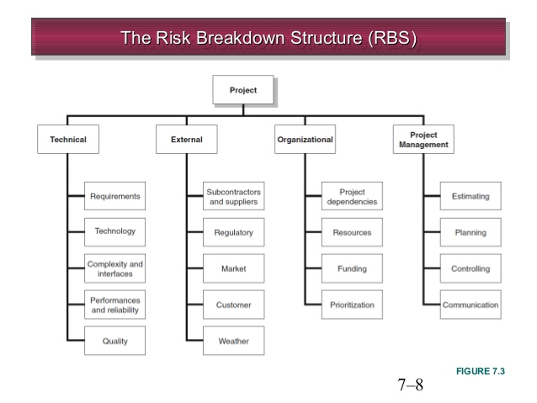

Figure 1 https://image.slidesharecdn.com/chapter7-managingrisk-140514041223-phpapp01/95/chapter-7-managing-risk-8-638.jpg?cb=1400042031

Risk probability is the chances that a risk that may occur during execution of projects. It is measured by percentage in the probability times impact in the P x I matrix used in qualitative analysis of risks. Risks probability cannot be 100% because that wouldn’t be a risk instead of an event that will happen in the project and cannot be 0% because it is not a risk if it doesn’t have chance happens at all. Risk impact is the severity of the risk of the impact on the project. It is calculated in form of cost, health, human life, or some critical factor. It is hard to tell that risk when will the risk happens and how it happens but what can be done is by doing analysis on the risks and come out with strategies that helps to mitigate the risks or avoid the risks. Probability x Impact Matrix is used to analyse the risk and categorise them into low risk, medium risk or critical risk. (Team, 2017)

Risk management process will be done by the risk management monthly to re-assess the risk register since it is a short-term project. Risk manager will re-assess each risk on the risk register to adjust the strategies used for each risk. Risks on the risk register will be updated by the risk manager.

### Identify Risk

Our team will be using Delphi technique and interview to identify the risk may happen in our project.

Delphi technique is a commonly used technique to achieve ideas or comments from the experts within their professional (Chia-Chien Hsu, Brian A. Sandford, 2007). A group of experts will be undergoing a questionnaire section and our team will extract the data from the questionnaire. Risk manager will analyse the data collected and come up with a risk register. Delphi technique applied in risk identification to help to identify the risk with higher accuracy. Delphi technique allows the project team to extract data from multiple experts in one shot which also helps to reduce the time required to conduct the risk identification process. Delphi technique also helps to avoid individual dominant in the discussion when collecting data from the experts. (Chia-Chien Hsu, Brian A. Sandford, 2007)

Interviews are conducted between experienced project participants, subject matter experts and stakeholders to understand what the status of the project is and analyse the situation. During the interview, various question will be asked and answered by the interviewee. Answers of the questions are analysed and added into the risk register. Interview provides depth understanding of a topic and helps to identify the potential risks in the project. (Berry, 1999)

Lesson learnt will also be one of the method for identifying risks in the project. Risk manager will analyse the situation from the previous team that handle the project and find out what is the root cause of the failure of project and the risks if our project team ignores the consequences. Lesson learnt is also a good method if there is a reference for the team to refer to. In our case, previous team that handle the project is the references for our team. (Inc., 2013)

**Risk Register**

Risk register is a documented list of risks that identify by the risk manager. It includes potential risks and identified risks. It is the outcome of the risk management process conducted by the risk manager. There are some important components that will included in the risk register which are the description of risk, risk owner, root cause, probability of the risk happening, impact of the risk, severity of the risk, strategies used to handle the risk etc. Risk register will be further updated with risk quantitative analysis and risk qualitative analysis by the risk manager.

Risk register requires input from departments as well as stakeholders or even end users of the system. Risk register provides the framework to the team on how to solve the risk and potentially avoid the risk. Risk register should be review by stakeholders and other department manager, if they found any risk that risk manager not yet identified, they will provide information on the unidentified risk and maybe the mitigate strategy for the unidentified risk.

### Perform Qualitative Risk Analysis

Perform qualitative risk analysis is to identify the severity of the risk in the project by combining the probability and the impact of the risk. The purpose of doing this analysis is allow the risk manager to control the risk based on the severity of the risk. Risk manager will be focus on the high-level risk and come out with a strategy that mitigate the risks or avoid the risk in the Project.

Probability, impact matrix will be used in the qualitative risk analysis for each of the risk in the risk register. Risks are assessed with their probability of occurring in the project and the impact of the risk to the project itself.

|  |  |  |  |  |  |  |
| --- | --- | --- | --- | --- | --- | --- |
|  | | Impact | | | | |
| 0.3 | 0.4 | 0.5 | 0.6 | 0.7 |
| Probability | 0.3 | 0.09 | 0.12 | 0.15 | 0.18 | 0.21 |
| 0.4 | 0.12 | 0.16 | 0.2 | 0.24 | 0.28 |
| 0.5 | 0.15 | 0.2 | 0.25 | 0.3 | 0.35 |
| 0.6 | 0.18 | 0.24 | 0.3 | 0.36 | 0.42 |
| 0.7 | 0.21 | 0.28 | 0.35 | 0.42 | 0.49 |

*Table 3: Risk Assessment Scoring with P x I*

The probability of the risk happen are scaled by the percentage of the occurrence of the event where the impact is also scaled by the percentage of the impact that the risk will deal to the project. The assessment score is multiplied by the probability score and impact score of the risks. Under 0.2 is green zone, 0.21 to 0.3 is orange zone and 0.3 above is red zone. Green represents low risk, orange represents moderate risk and the red represents high risks. (Manick, 2012)

Risks in the risk register will also go through a risk urgency assessment. Risk urgency assessment is a process that rank the priority of the risks by their timing of action need to happen first or later. Few elements need to consider while doing the risk urgency assessment including the time available, warning signs of risks and the risk assessment scoring. (Knowledge, 2017) Risks with higher risk assessment scoring means higher chance for the risk occur in the project. Risks with higher assessment score usually will have higher priority.

Risk categorisation also applied in our risk management plan. Risk categorisation technique is categorising the risk and easier to manage and solve in one go. Some risks can be categorised together and solve with one solution instead of splitting them as different task that requires more resources to solve the problem. Updated risk register shows the categorised risks that has almost the same characteristic and can be solve by using the same solution. (Babou, 2008)

### Perform Quantitative Risk Analysis

Expected Monetary Value (EMV) analysis is the calculation of the expected monetary value of a certain decision by given the probability and the impact of the risk that occur in project. It is used to calculate the profit or loss by the decision and express the profit or loss in by using table or decision tree diagram. EMV is used in quantitative risk analysis to calculate the cost of the action to address the risks in the risk register. It is calculated by probability multiplied by impact cost to get EMV.

### Plan Risk Responses

There are four types of risk response for the negative risks and four types of risk response for the positive risks. There are total eight distinct types of risk response.

**Negative Risk**

**Avoid** – One of the strategies is avoid the risk. Project team takes actions to eliminate the risks or protect the project from the impact of the risk. It usually making the project team to change their management plan or strategy used to approach the project to avoid the risk. The ultimate steps to avoid the risks is terminate the project completely to avoid further risks impacting the project. Some risks that can be avoided if information collecting, advises from SME or proper communication plan are done well during the project execution. (Project Management Institute, 2013)

**Transfer** – Transfer risk is the strategy to transfer the risk to a third party. By transferring the risk to the third party can let the third party to bear with the risk’s impact. Transferring the risk doesn’t mean the project team disown the risk but only shifts the responsibility to a third party. Third party usually will sign a contract by taking the risk and paid by risk premium. E.g. the project team hires vendors to complete their project’s module. (Project Management Institute, 2013)

**Mitigate** – Mitigation of risk is a risk response strategy where a series of action done by the project team to reduce the probability of occurrence or the level of the impact of risks. Mitigate risk means to control the impact of the risk until an acceptable range and try to recover the damage dealt by the risks. Having a backup for database is an example to mitigate the risk of database failure or messed up by someone. (Project Management Institute, 2013)

**Accept** – Acceptance of risk means the project team will not do anything until the risk happens. This strategy is applied to some risks that cannot be cost-effectively mitigate the risk or not possible to address the risk. Risk acceptance strategy doesn’t require the project team to change their management plan to address to risks. Risk acceptance can be passive or active, passive acceptance will only leave the team with a document on how to handle the risk until the risk occur. (Project Management Institute, 2013)

**Positive Risk**

**Exploit – Risk with positive impacts may response with the exploit strategy. This strategy ensures the positive effect of the risk is realized by get rid of uncertainty events happens. E.g. most skilled and experienced staffs are assigned to tasks to reduce the time to finish the tasks and using the latest technology to ease the difficulty of development or reduce the cost required to develop the module.** (Project Management Institute, 2013)

**Enhance – Enhance strategy is the opposite of the mitigate strategy for negative risk. It enhances the probability and the impact of positive risks. This strategy seeks for the best solution to increase the positive impacts and the probability of the occurrence of risks.** (Project Management Institute, 2013)

**Share – This strategy is used when the project team itself cannot get the best benefits from the positive risks. Instead of taking the ownership by the team itself where the positive effect of the risks cannot be maximised, sharing the opportunity partially or fully to third party where the third party can capture the full potential of the positive risk.** (Project Management Institute, 2013)

**Accept – Project team accept the positive effect from the risk but doesn’t actively commit for the risk.** (Project Management Institute, 2013)

### Control Risks

Risks identified needs to be control by implementing a risk response plan. Risk register also needs to be tracked down and update for the incoming risks. Risk manager should identify new risks that might threaten the project and evaluate the new identified risks. The purpose of control risks is to enhance the efficiency of the method that used by the risk manager to approach the risks. Risk control needs to be done by daily to track all the risk occurred in the project and updating the risk register which will be done along with the weekly meeting in our project.

**Risk Reassessment**

Risk reassessment including updating the risk register, remove the risks that no longer threaten the project and identify new risks. Risk re-assessment needs to be scheduled and carry out to accomplish the objectives of the project. Re-analyse on the risks identified helps to reduce the cost to address the risks as the impact of the risk will be re-analysed by the risk manager. Risk register will be constantly updated by the risk manager and shared to the stakeholders and team members.

**Risk Audits**

Risk audits, in other words is called “risk review” is carry out by the project manager to ensure the quality and accuracy of the risk identify by the risk manager. Risk audits should be often conducted to increase the effectiveness and reduce the mistakes done by the risk manager. Risk audits should be including the team members because team members can give ideas or even identifying new risk in the project. Our project team includes the risk audit in our weekly meeting.

**Meetings**

As mentioned at above, our team conduct the risk meeting along with the weekly meeting because all the stakeholders and project team members will be joining the weekly meeting. During that time is the best to carry out the process of risk controlling of the project. Discussion between attendees will help the risk re-assessment easier and the risk audits can be performed better.

| **Risk ID** | **Risk Categorization** | **Risk** | **Root Cause** | **Trigger** | **Probability** | **Impact** | **Impact (Monetary Value)** | **Priority** | **EMV** | **Response Strategy** | **Potential Response** | **Status** | **Risk Owner** |
| --- | --- | --- | --- | --- | --- | --- | --- | --- | --- | --- | --- | --- | --- |
| R-1 | Project Risk | The steering committee do not recall of being presented the project feasibility study by the Project Sponsor or the Project Manager to them. | communication between project team and steering committee is not properly conducted | Steering committee questioning about the budget, technical issue and operation issue | 0.4 | 0.5 | -$7,000.00 | 0.2 | -$2,800.00 | Mitigate Risk | Present the project feasibility study to the steering committee | Open | Project Manager |
| R-2 | Project Risk | The project approval was not formally documented. | Schedule of the project is so packed that team members doesn't have time to do the documentation | Documentation is not prepared by the team | 0.3 | 0.6 | -$10,000.00 | 0.18 | -$3,000.00 | Mitigate Risk | Get ready the project document and have meeting between steering committee to get the formal approval documented | Open | Project Manager |
| R-3 | Project Risk | There is no evidence that a proper project management process was followed. | Lack of managing skill on the project manager to keep the project management process up to date and document the process | Documentation is not done by the project manager and WBS is not done | 0.5 | 0.5 | -$7,000.00 | 0.25 | -$3,500.00 | Mitigate Risk | Using JIRA to manage the project and keep the JIRA up to date | Open | Project Manager |
| R-4 | Technical Risk | The PC and server hardware technical specifications were constantly being changed to suit new or added requirements. | Acceptance of the additional requirement of system without considering the hardware requirement or limit | Functional requirement specification document constantly updating and causing the system requires more advance hardware to support | 0.5 | 0.6 | -$10,000.00 | 0.3 | -$5,000.00 | Avoid Risk | Cancel / Reject some additional requirements of the system and give proper reasons to the client, accept additional requirements that will not cause issue to the project | Open | Business Analyst / Developer Team |
| R-5 | Technical Risk | Requirements keep coming in from users almost daily where the GITS-ADC Team Lead keeps on accepting them without hesitation. | Discussion between Business Analyst and Developers does not conduct before accepting new requirements from the clients | Functional requirement specification document constantly updating and causing modules of the system cannot finish in time | 0.5 | 0.6 | -$15,000.00 | 0.3 | -$7,500.00 | Avoid Risk | Cancel / Reject some additional requirements of the system and give proper reasons to the client, accept additional requirements that will not cause issue to the project | Open | Business Analyst / Developer Team |
| R-6 | Schedule Risk | There was redundancy of work performed as the Work Breakdown Structure (WBS) was done separately by each respective department and the Project Manager did not review and then consolidate those WBSs into one holistic WBS. | Departments leads doesn't communicate well and doesn't conduct meeting to discuss about WBS | Departments does not centralize their management and having multiple people have the right to approve member's work | 0.4 | 0.7 | -$10,000.00 | 0.28 | -$4,000.00 | Avoid Risk | Conduct review on the WBS from respective department and resolve redundancy of work then finally rework on the final WBS | Open | Department Leads |
| R-7 | Schedule Risk | Most of the team members have been focusing more on their daily operation support rather than tasks being assigned by the Project Manager or their respective Team Lead. | improper communication medium was used in the conversation between team members and team lead | Progress on the module is not increasing during daily progress reporting | 0.3 | 0.5 | -$5,000.00 | 0.15 | -$1,500.00 | Accept Risk | Have a meeting with discussion on the issues and promote various communication medium to the team to help the team lead or project manager easier to assign tasks and track their job progress | Open | Team Lead / Project Manager |
| R-8 | Schedule Risk | tasks are performed without prioritizing other dependent tasks. | WBS not well scheduled and wrong priority tasks are assign to the members | there is no progress on the critical tasks | 0.3 | 0.5 | -$5,000.00 | 0.15 | -$1,500.00 | Mitigate Risk | Scrum meeting held daily for tracking the high priority tasks and adjustment on the pending tasks base on priority | Open | Scrum Master |
| R-9 | Financial Risk | IT assets acquisition and spending were through PROC Manager with suppliers without going through a proper tendering process. | PROC Manager might have relationship with the suppliers that leads to improper tendering process and letting the supplier get the winning of the bidding | PROC Manager does not have the evidence that show the tendering process is officially going through a proper tendering process | 0.3 | 0.4 | -$10,000.00 | 0.12 | -$3,000.00 | Accept Risk | Ask PROC Manager to deal with the suppliers in a proper tendering process | Open | PROC Manager |
| R-10 | Financial Risk | purchasing of IT assets without a proper tendering process has led to overrun by budget. | Comparison between supplier are not done properly and trust issue of some proposals by company that doesn't have fame in the community | Weekly meeting finds out the budget allocated on some unnecessary stuffs | 0.4 | 0.6 | -$15,000.00 | 0.24 | -$6,000.00 | Avoid Risk | Reduce the cost of future assets | Open | PROC Manager |
| R-11 | Schedule Risk | the testing plan was not developed yet. | Interns doesn't have the confidence to write the testing plan and their supervisor doesn't guide them well | Quality Assurance Team keep delay their job | 0.7 | 0.6 | -$10,000.00 | 0.42 | -$7,000.00 | Mitigate Risk | Quality Assurance Team lead should keep the tasks on track and chase members to finish their job on time | Open | Quality Assurance Team Lead |
| R-12 | Financial Risk | there was not even a clear designated sponsor (or sponsors) for the project. | Budget planning and proposal of the project are poorly documented causing sponsor lose their trust to the project | sponsors are not agreeing with the project | 0.4 | 0.7 | -$5,000.00 | 0.28 | -$2,000.00 | Avoid Risk | Write a better proposal and look for sponsors | Open | Financial Manager |
| R-13 | Project Risk | there was no clear project organizational structure to manage the project. | Steering committee / project manager does not develop an organizational structure for the project or assign a people who will take the highest right to manage the project | Departments leads are overridden other departments lead's responsibility and authority | 0.6 | 0.7 | -$20,000.00 | 0.42 | -$12,000.00 | Avoid Risk | Develop an organizational structure for the project and assign the highest right to the project manager to manage the project | Open | Steering Committee |
| R-14 | Project Risk | the Project Manager’s authority was constantly overridden by the department head /managers. | Organizational structure is not clearly stated and misunderstanding on the authority of department heads | Project manager doesn't have the authority to match with his position | 0.5 | 0.7 | -$20,000.00 | 0.35 | -$10,000.00 | Avoid Risk | Develop an organizational structure and conduct a meeting to let department heads understand their authority | Open | Steering Committee |
| R-15 | Technical Risk | technical skills were especially lacking in the network and security areas. | Developer team lack of training and experience | System attacked by unauthorized anonymous | 0.4 | 0.7 | -$10,000.00 | 0.28 | -$4,000.00 | Transfer Risk | Outsource modules to vendors | Open | HR Department |
| R-16 | Project Risk | there were no monitoring reports to review as none were prepared and formally documented. | Responsibility of each team lead are improperly listed or not informed to the team lead | There is no reports or documents that supports monitoring job was done in weekly meeting | 0.5 | 0.6 | -$5,000.00 | 0.3 | -$2,500.00 | Avoid Risk | Team Leads are advised to write monitoring reports and submit to project manager on weekly basis | Open | Project Manager |
| R-17 | Project Risk | the risks associated with the project, although documented, had no detailed action plans and were not categorized in terms of impact or severity. | Risk management are not well planned since the project start | Team members are in panic mode when risks strike | 0.6 | 0.7 | -$15,000.00 | 0.42 | -$9,000.00 | Mitigate Risk | Revise the risk register and implement action plans for each risk, categorize risks in terms of impact or severity or risk assessment score | Open | Project Manager |
| R-18 | Technical Risk | the hardware and software delivery was still being negotiated with some potential vendors while there were only four (4) months to complete the project. | Negotiation results are not satisfied by both parties | Hardware is not found in the storeroom and development software is unlicensed product / open source software | 0.4 | 0.5 | -$5,000.00 | 0.2 | -$2,000.00 | Transfer Risk | Conduct negotiation with the hardware and software vendors and come out with the result where both parties are satisfied | Open | PROC Manager |

### Conclusion

In a nutshell, risk management of a project is essential for the project team. Proper risk management can lead to the success of the project whereas poor risk management will lead to failure or even worse. Risk management should be done properly to increase the success rate of the project and team work plays a key role in it. Risk management requires sources from other departments as well as the stakeholders or even the end users of the system.

## Procurement – Thum Choon Tat TP030470

### Introduction

Project procurement management manages the project resources such as products, services, or part of the project deliverables managed by third party suppliers (Project Management Institute, 2013). The project resource management process includes procurement planning, conduct procurements, control procurements and procurement closing. In an IT project, project management procurement includes the processes of managing IT assets and outsource part of the project deliverables to third party software vendors.

Below are the overview phases of project procurement management based on Project Management Body of Knowledge:

|  |  |
| --- | --- |
| Phase | Description |
| Plan procurement management | Process of documenting project procurement decisions, specifying the approach and identifying potential software vendors and hardware suppliers. |
| Conduct procurements | Process of obtaining responses from software vendors, selecting software vendors and awarding a contract. |
| Control procurements | Process of managing procurement relationships, monitoring contracted software vendors’ and hardware suppliers’ performance and making changes and corrections if applicable. |
| Close procurements | Process of completing project procurements and termination of contracts. |

Table : Project procurement management phases

### Plan procurement management

Procure management planning is the first phase of project procurement management, which is the process of defining procurement requirements of the project from procurement development till the contract termination process (Piscopo, 2013) and documentation on the project procurement decisions, specifying the approaches and identifying the software vendors and hardware suppliers (Project Management Institute, 2013). The decision on the hardware purchases and software modules to be outsourced will go through “Make-or-buy analysis”, “Expert Judgement”, “Market Research” and “Meetings” techniques.

#### Procure management plan

Procurement management plan defines the procurement requirement for the project with managing the contracts awarded to the vendors (Mark, 2013). The main contents of procurement management plan include the type of contract to be used for the contracted vendors, vendors’ selection criteria and contract approval processes. The full content with brief description on the contents of procurement management plan document are as follow:

|  |  |
| --- | --- |
| **Content Title** | **Description** |
| Procurement management approach | Defines the necessary steps and responsibilities for the entire procurement process |
| Procurement definition | Describe the items including but not limited to hardware and software to be procure. |
| Types of contract to be used | Describe the type of contracts to be awarded to successful bidders |
| Procurement risks | Identify and list out the potential risk in procurement management |
| Procurement risks management | Defines the methods and plans to manage the risks. |
| Cost determination | Defines the cost determination techniques to be used in buyers’ selection criteria |
| Standardised procurement documentation | Describe the standard of the procurement documentation. May include document templates. |
| Procurement constraints | Describe the constraints within the procurement management. May be related to schedule, cost, scope and more. |
| Contract approval process | Defines the process of contract approval based on the decision criteria. |
| Decision criteria | Defines the criteria required for selecting successful bidders. |
| Vendor management | Describes the roles and action of procurement team to ensure the contracted vendors provide the deliverables agreed |
| Procurement activities performance matrix | Records the performance of the vendors on delivering the deliverables with scale. The scales may vary among companies. |
| Sponsor acceptance | Signature of project sponsors to indicate the approval of the procurement management plan |

#### Statement of work

Procurement statement of work describes the task to be accomplished and the deliverables by the contractor (INC, 2015), included in the procurement management plan templates. SOW content includes the scope of work, expected deliverables, responsibilities, contract timeline including fee schedule and deliverables completion criteria. The full content with short description on the contents of statement of work document are as follow:

|  |  |
| --- | --- |
| **Content Title** | **Description** |
| Period of performance | Defines the start date and end date of the contract |
| Engagement resources | Describe the resources needed during the work process |
| Scope of work | Defines the detail and concise scope of deliverables which the vendor required to deliver |
| Contractor responsibilities | Defines the responsibility of the contractor or vendor agreed upon the contract |
| Client responsibilities | Defines the responsibility of the client or buyer agreed upon the contract |
| Fee schedule | Defines the payment regulations with defined payment schedule. |
| Our-of-pocket expenses | Defines the regulation on the payments made by the client on out-of-pocket expenses (may include meals and local transportation fees) |
| Completion criteria | Defines the criteria of completion and ending of the contract. |
| Assumptions | Defines the assumption which are specific for the contracted project / deliverables |
| Project change control procedure | Defines the procedure required to follow when project specification changes take place |

#### Other procurement documents

##### Request for Information (RFI)

Request for Information (RFI) document is used to gather information from the vendors in formal and structured way (Indiana University of Pennsylvania, 2015). This document is used when there are multiple potential vendors and not enough information on the vendors’ profile (Purchasing & Procurement Center, 2015). RFI document will be used to prepare RFQ and RFP document.

##### Request for Quotation (RFQ)

Request for Quotation (RFQ) document is used to obtain detail information on the vendor’s proposal on delivering the buyer’s requirement with the proposed cost (Mhay, 2008). The information collected form RFQ will be used to determine the vendors to be contracted.

##### Request for Proposal (RFP)

Request for Proposal (RFP) document is used to invite the vendors to submit their proposal on the buyer’s desired goods or service (Tendersinfo, 2012). The main goal of this document is to identify the suitable vendors to meet the buyer’s needs.

##### Invitation for Bid (IFB)

#### Items to be procured

For Global Supply Chain Management Project, the following hardware and software need to be included in the plan procurement management process:

##### Hardware

Hardware is required to develop Global Supply Chain Management Software as well as the execution of the deliverables during production phase. The hardware required for GSCMP are as below:

|  |  |
| --- | --- |
| Hardware | Description |
| Computer devices | Required for the development of Global Supply Chain Management Software including software debugging and monitoring. |
| Servers | Act as the data processing centre for GSCMP deliverables as well as incoming web requests. |
| Server racks | Act as the container for servers. |
| Network switch | Use to establish connection to multiple electronic devices |
| Modem | Provide network connection between server and public network. |
| Router | Provide local network routing service. |
| LAN cables | Wired connection between electronic devices. |
| Uninterruptable power supply | Provides emergency power supply for servers to shut down in case of power supply breakdown. |

As the project team, had previously purchased new hardware frequently and the delivery process of these hardware are still being negotiated with potential vendors, the procurement team will require identifying the hardware that has been purchased and develop a plan to purchase the remaining required hardware in market research process.

Due to the overfunded budget on hardware and software, the procurement team will require comparing the required hardware prioritizing the hardware fees from different vendors in market research process. Meetings with the hardware vendors can be conducted to bid for a lower price of the hardware. Expert judgement will be done after all the hardware vendors made their proposals to identify the hardware vendors to be purchased from.

##### Software

As Global Supply Chain Management Project has a short leftover timeline left to deliver the deliverables and the progress of this project is slow, part of the deliverables is required to be outsourced to third party software vendors to deliver the software in time.

In make-or-buy analysis, the procurement team decided on the software modules to be outsourced based on development team abilities and time required to deliver the software modules and current project budget (Project Management Institute, 2013). If the project team is unable to deliver a software module due to lack of technical skills, the software module must be outsourced to third party software vendors. As the purchasing of IT assets has lead the project budget to be overfunded, the procurement team will be required to consider contracting the best software vendors with lower cost in market research technique. The selected software module that will be outsourced to third party vendors are:

* Transportation management module
* Yard management module
* Manufacturing management module
* Inventory management module
* Product management module
* Customer requirements module

In market research, the procurement team will look for third party software vendors as bidders to outsource the selected software modules. The procurement team need to make sure that the selected bidders has the capability to deliver the outsourced modules during market research. Meetings with the bidder can be conducted to gather more information on the bidders’ capabilities. The outsourcing software modules are divided equally into 2 groups, which requires the software vendors to choose one of the groups to be contracted. The grouping of the modules are as follows:

|  |  |
| --- | --- |
| Group A | Group B |
| Transportation management module | Yard management module |
| Manufacturing management module | Inventory management module |
| Product management module | Customer requirements module |

#### Contract types

A contract is a legally binding agreement between two or more parties (Usmani, 2014). The contract categories available for procurement management are Fixed-Price Contract, Cost Reimbursable Contract and Time & Materials. The description on the procurement contract types are described in the table below:

|  |  |
| --- | --- |
| **Contract category** | **Description** |
| Fixed-Price contract | The agreement on the tasks, cost and time are fixed after the contract has been signed |
| Cost Reimbursable Contract | The seller is reimbursed for meeting or exceeding the selected project deliverables and objectives. |
| Time and Materials | Mixture of both Fixed-Price Contract and Cost Reimbursable Contract. |

In this project, the contract type that will be used to award the successful bidders is Firm Fixed-Price Contract in Fixed-Price Contract category due to the constraint in project timeline and the constraint in project budget.

#### Procurement team roles and responsibilities

|  |  |  |
| --- | --- | --- |
| **Role** | | **Responsibility** |
| Project Manager | | Overall coordination of procurement programs |
| Procurement Manager | | Collaborate with project manager to make decision on procurement items specification. |
| Procurement Team | Procuring Officer | Directly communicate and negotiate with vendors and prepares a list of potential vendors |
| Legal advisor | Provide advice on contracts and assist in negotiation with vendors |
| Business Analyst | | Drafting the specification of the items to be procured |

### Conduct procurement

Conduct procurement is the process of obtaining the venders’ response, selecting venders and awarding contract to the vendors (Project Management Institute, 2013). In this process, the procurement team will require obtaining software vendors’ response by advertising the contracts to the bidders found during market research on the capable software vendors. Below is the schedule for conduct procurement process:

|  |  |  |  |
| --- | --- | --- | --- |
| **Task name** | **Start date** | **End date** | **Duration** |
| Advertise Job | Fri 17/3/17 | Wed 22/3/17 | 5 days |
| Conduct Bidder Conference | Thu 23/3/17 | Thu 23/3/17 | 1 day |
| Job Proposal Review | Fri 24/3/17 | Fri 24/3/17 | 0.5 days |
| Award Contract to Vendors | Fri 24/3/17 | Fri 24/3/17 | 0.5 days |

To ensure that all selected software vendors have clear understanding on the software module requirements, the procurement team can conduct bidder conference. Before the bidder conference begin, the procurement team should develop evaluation criteria for the selection of the software vendors. The developed evaluation criteria should not be revealed to the bidders. The evaluation criteria for choosing the software vendors are:

* Proposed cost within project budget
* Proposed development time within project timeline
* Experience on delivering similar software module

During bidder conference session, the procurement team should hear questions raised by the bidders and answer those questions (Project Management Institute, 2013). Before ending the bidder conference session, the procurement team will announce the deadline of the proposals from the software vendors. At the end of the bidder conference, the software vendors will begin developing their proposal.

After collecting proposals from the bidders, the bids will be evaluated by the procurement team based on the evaluation criteria built. The procurement team can use scoring technique in tender evaluation matrix to determine the vendors to be contracted. The vendors to be contracted will be determined based on the total score of the criteria listed in the matrix. A sample of the evaluation matrix is attached in appendix B.

As the plan for outsourcing the software modules are outsourcing 3 software modules as a package to one software vendor, bidders with the highest total score on a software module package will be awarded with a contract. Once the 2 winning bidders are chosen, the bidders will be awarded with a contract. Before awarding contract to the successful bidders, the procurement team will require conducting meetings with the successful bidders for procurement negotiation. The purpose of procurement negotiation is to clarify the requirements and other terms related with the contract on the outsourced software module so that agreement can be reached for both parties on the contract (Project Management Institute, 2013). Members from different team within Global Supply Chain Management Project may join the procurement negotiation to aid and clarification on the software module requirements.

Once both software vendors and GSCMP team are on the agreement of the final contract content, the procurement team will require preparing an agreement document to the successful bidders. An agreement can be called as a contract, subcontract or a purchase order (Project Management Institute, 2013). The agreement document content may be varying based on the type of contract used.

### Control procurement

Control procurement is the process of managing procurement relationships, monitoring contract performance and making changes to the contracts (Project Management Institute, 2013). In this process, the procurement team will require monitoring contracted software vendors’ performance and modification of the original contracts with requirements change requests.

#### Change request

When the outsourced software module requirement changes, the procurement team will require obtaining the approval document of the change request. This document can affect the original content of the contract awarded to software vendors. The content of this document may include changes in statement of work, pricing or descriptions of the deliverables (Project Management Institute, 2013).

For each requirement changes on the outsourced software module, the contracted software vendor and procurement team will require conducting contract change control system. Change control system which includes the change request document allows the change request to be analysed, approved, declined and managed (Phillips, 2013). A new contract will be given to the software vendors after the agreement on the change request.

#### Performance monitoring

Monitoring software vendors’ performance is part of the control procurement process, which monitor the progress and quality of the software vendors as compared with the awarded contract (Project Management Institute, 2013). The purpose of monitoring software vendors’ performance is to identify the performance success or failure as a part of risk management. The performance of software vendors can be recorded through performance reporting and inspections process.

In performance reporting, the performance data of the software vendors will be evaluated against the agreement requirement (Project Management Institute, 2013). The progress of the software vendors can be tracked by sending daily progress report from the software vendors. The format of the report can be varying depends on the reporting format of the software vendors.

Inspection and audit is required by the contractor to monitor the performance of the contracted vendors (Project Management Institute, 2013). This process can be conducted during the execution phase of the project. Representatives from the respective software vendor’s procurement team may join the inspection and audit if the agreement is made in the contract.

#### Payment system

Payments by the contractor to the software vendors are done by the contractor’s accounts payable system (Project Management Institute, 2013). In GSCMP, the outsourced software modules are breaking down into software components. The payments will be received by the software vendors for each of the software components completed. The payment figure may be altered based on the comparison of the deliverables with the expected output from the software vendors in close procurement process. The maximum payable amount for the software components in the outsourced modules are listed below:

|  |  |  |
| --- | --- | --- |
| **Software module** | **Software component** | **Payable amount** |
| Transportation Management Module | Transportation Execution | $3,000.00 |
| Transportation Follow-up | $3,000.00 |
| Transportation Measurement | $4,000.00 |
| Yard Management Module | Yard Shipment Process | $1,000.00 |
| Gate Control | $3,000.00 |
| Dock Management | $3,000.00 |
| Seal Management | $3,000.00 |
| Manufacturing Management Module | Production Process Control | $3,500.00 |
| Workflow Simulation | $1,000.00 |
| Resource Planning | $1,000.00 |
| Assembly Line Optimization | $3,500.00 |
| Factory Layout Planning | $1,000.00 |
| Inventory Management Module | Stock Tracking | $3,000.00 |
| Loading & Unloading | $1,500.00 |
| Inventory Mix Optimization | $4,000.00 |
| Optimal Inventory Report | $1,500.00 |
| Product Management Module | Product Catalogue Management | $4,000.00 |
| Product Information Management | $3,000.00 |
| Packaging | $3,000.00 |
| Customer Requirements Module | Checking Stock Availability | $4,000.00 |
| Processing Requirements | $2,000.00 |
| Feedback Collection | $4,000.00 |

#### Claims administration

Claims administration takes place when the sellers, which are vendors is unable to reach an agreement on the contested changes, also variously called as claims (Project Management Institute, 2013). Claims administration also manages the changes of the contracts between buyer and sellers (Projex Academy, 2016). If any of the software vendors is unable to reach an agreement on the requirement changes, the claims are required to be resolved by both parties through negotiations. If both procurement team and software vendors are not willingly to resolve the claim, the claim can be resolved through the court system (Projex Academy, 2016).

#### Records management system

Records management system is used by project manager to manage project documents including contracts and procurement document (Project Management Institute, 2013). All documents created in procurement processes must be recorded to maintain the audit trail (Lynch, 2013) including procurement plan and contracts.

### Close procurement

Close procurement is the process of completing each procurement (Project Management Institute, 2013). In this process, the procurement team will document the agreements and other related documents for future reference and terminates the contracts with software vendors. The information gathered in close procurement process can be used as the basis for contractor evaluations. The sub processes that requires the procurement team to conduct are:

#### Procurement audit

Procurement audit is the process of reviewing the procurement process from plan procurement process to control procurement process (Project Management Institute, 2013). The information gathered during the procurement review such as the performance of the software vendors can be used by GSCMP procurement team to make decision in future procurement process.

#### Procurement negotiations

The main purpose of procurement negotiations is to resolve the outstanding issues, claims and disputes (Project Management Institute, 2013). If the contracted software vendors deliver their deliverables with defects such as bugs in the software module, the procurement team will negotiate with the software vendors to resolve the issues. An example of the solution will be reducing the payment to the software vendors.

#### Contract closure

After the procurement audit and negotiations, the procurement team will close the procurement by closing the contract with the software vendors and provide a formal contract termination notice (Project Management Institute, 2013). The contract closing process may fall into one of the categories:

* Fulfilment by performance

The seller has completed their work successfully

* Mutual Agreement

Bad relationships between buyer and seller

* Frustration  
  The procurement process face situations beyond control
* Operation of law

Procurement process face situations that requires action to be taken by court

#### Lesson learned documentation

Before the ending of procurement closing process, the procurement team will require preparing lesson learned documentation (Project Management Institute, 2013) to record their experience with the software vendors and may include procurement improvement recommendations. The records will be used to improve future procurement processes.

### Conclusion

Procurement management plays a key role in a project to manage products and services outside the project team such as project equipment and part of the system modules. From the lessons learned document, the procurement team should have more understanding on the performance of the contracted vendors and may use the information for future procurement process. Procurement team’s relationship with the sellers must be maintained for the benefit of future procurement process.

# References

Atlassian, 2017. *JIRA 6.4 Documentation.* [Online]   
Available at: https://confluence.atlassian.com/jira064/using-the-issue-navigator-720416597.html  
[Accessed 29 March 2017].

Babou, 2008. *Why do we need to categorize risks?.* [Online]   
Available at: https://leadershipchamps.wordpress.com/2008/06/02/why-do-we-need-to-categorize-risks/

Balanced Scorecard Institute, 2017. *What is a Key Performance Indicator (KPI)?.* [Online]   
Available at: http://www.balancedscorecard.org/Resources/Performance-Measures-KPIs  
[Accessed 29 March 2017].

Berry, D. R. S. Y., 1999. *Collecting data by in-depth interviewing.* [Online]   
Available at: http://www.leeds.ac.uk/educol/documents/000001172.htm

Bisk, 2017. *Effective Negotiation Techniques.* [Online]   
Available at: https://www.notredameonline.com/resources/negotiations/effective-negotiation-techniques/#.WOMyTDuGNhE  
[Accessed 4 April 2017].

Boundless, 2016. *Herzberg's Two-Factor Theory.* [Online]   
Available at: https://www.boundless.com/management/textbooks/boundless-management-textbook/organizational-behavior-5/employee-needs-and-motivation-46/herzberg-s-two-factor-theory-239-6609/  
[Accessed 29 March 2017].

BusinessDictionary, n.d. *Formal communication.* [Online]   
Available at: http://www.businessdictionary.com/definition/formal-communication.html  
[Accessed 28 March 2017].

Chapman, A., 2013. *Tuckman Model.* [Online]   
Available at: http://www.businessballs.com/tuckmanformingstormingnormingperforming.htm  
[Accessed 28 March 2017].

Chia-Chien Hsu, Brian A. Sandford, 2007. The Delphi Technique: Making Sense Of Consensus. *Practical Assessment, Research & Evaluation.*

ClearFit, 2012. *Hiring and Recruiting — Five best methods used by recruiters that your business should know.* [Online]   
Available at: https://www.clearfit.com/blog/hiring-and-recruiting-five-best-methods-used-by-recruiters-that-your-business-should-know/  
[Accessed 28 March 2017].

Doglione, C., 2016. *Understanding Responsibility Assignment Matrix (RACI Matrix).* [Online]   
Available at: https://project-management.com/understanding-responsibility-assignment-matrix-raci-matrix/  
[Accessed 23 March 2017].

Dontigney, E., 2011. *5 Conflict Management Strategies.* [Online]   
Available at: http://smallbusiness.chron.com/5-conflict-management-strategies-16131.html  
[Accessed 29 March 2017].

Excel Templates, 2013. *Forecasting Report.* [Online]   
Available at: http://exceltemplates.net/financial/financial-report/forecasting-report-template/  
[Accessed 29 March 2017].

Free-Management-eBooks, 2015. *Developing the Human Resources Plan.* [Online]   
Available at: http://www.free-management-ebooks.com/faqpm/team-02.htm  
[Accessed 23 March 2017].

Goudar, J., 2010. *Effective Project Communication Management.* [Online]   
Available at: http://www.projectperfect.com.au/white-paper-effective-project-communication-management.php  
[Accessed 28 March 2017].

Huddle, 2016. *10 Quick and Easy Team Building Activities.* [Online]   
Available at: https://www.huddle.com/blog/team-building-activities/  
[Accessed 28 March 2017].

HumanMetrics Inc., n.d. *Conflict Management Techniques.* [Online]   
Available at: http://www.personalityexplorer.com/freeresources/conflictmanagementtechniques.aspx  
[Accessed 29 March 2017].

Inc., C., 2013. *Risk Identification Methods - 12 Types.* [Online]   
Available at: https://manager.clearrisk.com/Resources/RiskTool/Risk_Identification_Methods_-_12_Types

INC, R., 2015. *SOW Template & Writing Guide.* [Online]   
Available at: http://www.rfpsolutions.ca/rfpportal/index.php?option=com_content&view=article&id=92&Itemid=134

Indiana University of Pennsylvania, 2015. *Request for Information RFI - How To - Procurement - IUP.* [Online]   
Available at: http://www.iup.edu/procurement/howto/request-for-information-rfi/

Ishikawa, K., 1990. *Introduction to quality control.* Tokyo: 3A Corp..

Ishikawa, K., 1992. *Guide to quality control.* 2nd ed. Tokyo: Asian Productivity Organization.

K., D., 2014. *Maslow's Hierarchy of Needs.* [Online]   
Available at: https://www.learning-theories.com/maslows-hierarchy-of-needs.html  
[Accessed 28 March 2017].

Klein, C. et al., 2009. Does Team Building Work?. *Small Group Research,* 16 January, 40(2), pp. 181-222.

Knowledge, P. M., 2017. *Risk Urgency Assessment.* [Online]   
Available at: https://project-management-knowledge.com/definitions/r/risk-urgency-assessment/

Luxoft, 2017. *Gamify!.* [Online]   
Available at: https://marketplace.atlassian.com/plugins/com.sentinel.confluence.plugin.gamify-core/server/overview  
[Accessed 29 March 2017].

Lynch, j., 2013. *Procurement Record Keeping - The Procurement ClassRoom.* [Online]   
Available at: http://procurementclassroom.com/procurement-record-keeping/

Mande, 2013. *What is the inspection and test plan (ITP)?.* [Online]   
Available at: https://ngsuyasa.wordpress.com/2013/12/24/what-is-the-inspection-and-test-plan-itp/  
[Accessed 11 April 2017].

Manick, 2012. *Probability And Impact Matrix.* [Online]   
Available at: http://www.justgetpmp.com/2012/02/probability-and-impact-matrix.html

Margaria, T., 2010. *Leveraging Applications of Formal Methods, Verification, and Validation 4th International Symposium on Leveraging Applications, ISoLA 2010 Heraklion, Crete, Greece, October 18-21, 2010 Proceedings, Part I.* Berlin, Springer-Verlag.

Mark, 2013. *Procurement Management Plan Template.* [Online]   
Available at: http://www.projectmanagementdocs.com/project-planning-templates/procurement-management-plan.html#axzz4cb9OtyZS

Mark, 2014. *5 Psychological Theories of Motivation to Increase Productivity.* [Online]   
Available at: https://contactzilla.com/blog/5-psychological-theories-motivation-increase-productivity/  
[Accessed 28 March 2017].

Mhay, S., 2008. *What is RFQ RFT RFP RFI in Procurement | Negotiation Experts.* [Online]   
Available at: http://www.negotiations.com/articles/procurement-terms/

Mishra, S., 2007. *Human Resource Management in a Project.* [Online]   
Available at: http://www.sswm.info/sites/default/files/reference_attachments/MISHRA%202007%20Human%20Resource%20Management.pdf

Nogueira, M., 2017. *Why Communication is so important for a Project Manager?.* [Online]   
Available at: https://www.linkedin.com/pulse/why-communication-so-important-project-manager-mauro-nogueira  
[Accessed 28 March 2017].

ODwyer, M. & McDonough, M., 2011. *Quality Planning for a Project.* [Online]   
Available at: http://www.brighthubpm.com/change-management/69342-quality-planning-for-a-project/  
[Accessed 11 April 2017].

Pattison, K., 2010. *Chip Conley Took the Maslow Pyramid, Made It an Employee Pyramid and Saved His Company.* [Online]   
Available at: https://www.fastcompany.com/1685009/chip-conley-took-maslow-pyramid-made-it-employee-pyramid-and-saved-his-company  
[Accessed 29 March 2017].

Phillips, J., 2013. *Defining the Change Control System.* [Online]   
Available at: http://josephphillips.com/defining-the-change-control-system/

Piscopo, M., 2013. *Procurement Management Plan Template.* [Online]   
Available at: http://www.projectmanagementdocs.com/project-planning-templates/procurement-management-plan.html

Piscopo, M., 2017. *Human Resource Plan.* [Online]   
Available at: http://www.projectmanagementdocs.com/project-planning-templates/human-resource-plan.html#axzz4dFPz1mL4  
[Accessed 4 April 2017].

Pitagorsky, G., 2012. *Status Reporting, Clarity And Accountability.* [Online]   
Available at: https://www.projecttimes.com/george-pitagorsky/status-reporting-clarity-and-accountability.html  
[Accessed 29 March 2017].

Project Management Institute, 2013. *A Guide to the Project Management Body of Knowledge.* Fifth Edition ed. Newtown Square(Pennsylvania): Project Management Institute, Inc..

Project Management Institute, 2017. *Pulse of the Profession 2017,* s.l.: s.n.

Projex Academy, 2016. *Control Procurements process - PMP Primer Video eLearning.* [Online]   
Available at: http://www.pm-primer.com/control-procurements-process/

Purchasing & Procurement Center, 2015. *RFI, RFP, RFQ.* [Online]   
Available at: http://www.purchasing-procurement-center.com/rfi-rfp-rfq.html

Ryan, M., R. & Deci, E. L., 2000. Intrinsic and extrinsic motivations: Classic definitions and new directions. *Contemporary educational psychology,* 25(1), pp. 54-67.

Stevens, M., 2016. *The Do's & Don'ts Of Sharing Sensitive Information With Vendors.* [Online]   
Available at: https://www.bitsighttech.com/blog/sharing-sensitive-information-vendors  
[Accessed 3 April 2017].

Team, M. T. E., 2017. *Risk Impact/Probability Chart.* [Online]   
Available at: https://www.mindtools.com/pages/article/newPPM_78.htm

Tendersinfo, 2012. *Procurement Process: What is Request for Proposal (RFP) | Tendersinfo Blogs.* [Online]   
Available at: http://www.tendersinfo.com/blogs/procurement-process-what-is-request-for-proposal-rfp/

The Communication Toolbox, 2008. *Types of Communication Medium.* [Online]   
Available at: http://www.communicationtoolbox.com/types_of_communication_medium.html  
[Accessed 28 March 2017].

The Myers & Briggs Foundation, 2017. *MBTI® Basics.* [Online]   
Available at: http://www.myersbriggs.org/my-mbti-personality-type/mbti-basics/  
[Accessed 28 March 2017].

University, M., 2017. *ROLES AND RESPONSIBILITIES IN RISK MANAGEMENT.* [Online]   
Available at: http://www.marquette.edu/riskunit/riskmanagement/roles.shtml

Usmani, F., 2012. *Performance Reports in Project Management.* [Online]   
Available at: https://pmstudycircle.com/2012/03/performance-report-in-project-management/  
[Accessed 22 March 2017].

Usmani, F., 2012. *What is a Matrix Organization Structure?.* [Online]   
Available at: https://pmstudycircle.com/2012/08/what-is-a-matrix-organization-structure/  
[Accessed 23 March 2017].

Usmani, F., 2014. *Types of Procurement Contracts used in Project Management.* [Online]   
Available at: https://pmstudycircle.com/2013/12/types-of-procurement-contracts-used-in-project-management/

Vliet, V. v., 2014. *Five Forms of Power (French & Raven).* [Online]   
Available at: http://www.toolshero.com/leadership/five-forms-of-power-french-raven/  
[Accessed 29 March 2017].

Whitaker, S., 2012. *Responsibility and Authority in Project Management.* [Online]   
Available at: http://seanwhitaker.com/responsibility-and-authority-in-project-management/

Wideman, R. Max & Aaron J. Shenhar, 2002. MBTI and Suitability to Project Work. In: *Project Management for Business Professionals: A Comprehensive Guide.* s.l.:John Wiley & Sons, p. 375.

# Appendices

Appendix A – Human Resource Plan Template

Appendix B – Tender Evaluation Sheet Template

Appendix C – Communication Management Plan Template

Appendix D – Progress Report Template

Appendix E – Status Report Template

Appendix F – Forecast Report Template

Appendix G – Document Softcopy